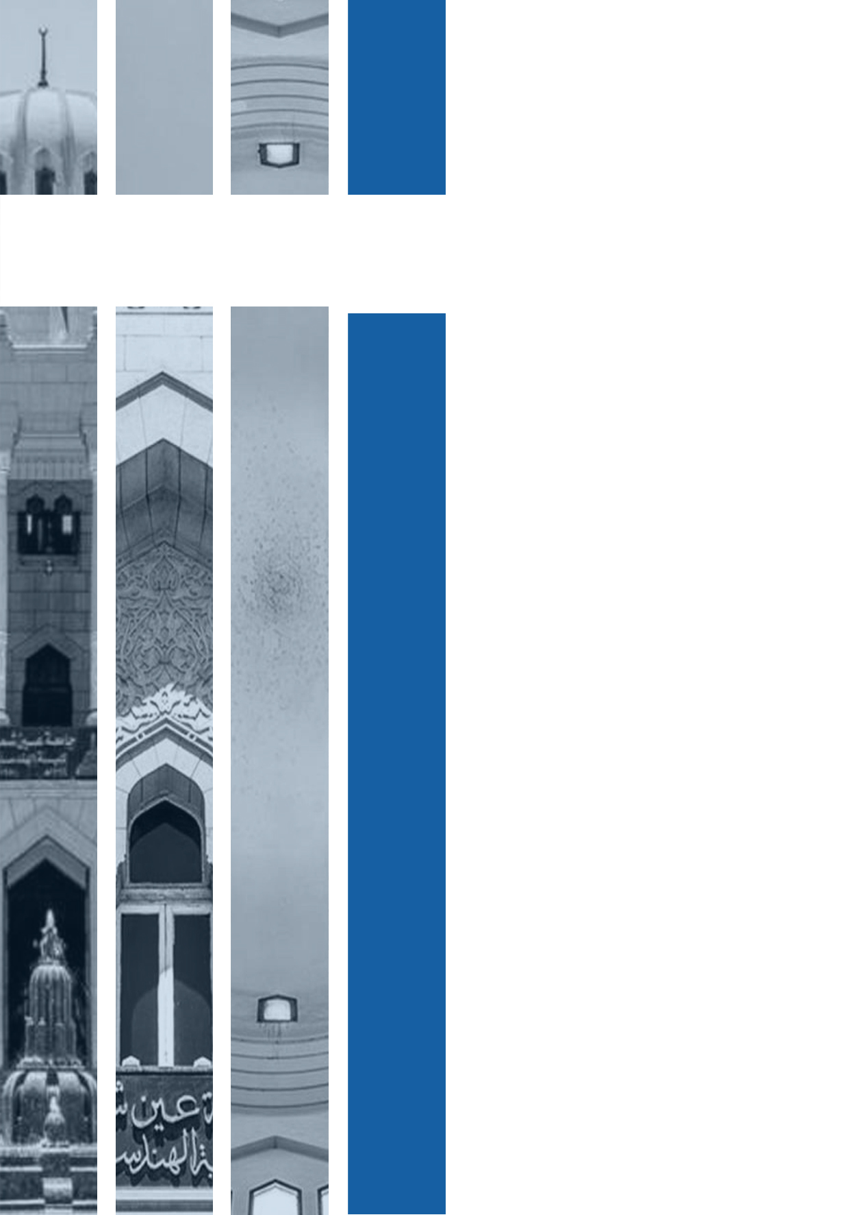

**Program: Computer Engineering and Software Systems**

***Course Code: CSE232***

***Course Name: Advanced Software***

***Submitted to***

**Prof. Gamal Abdel Shafy**

**Eng. Sally Shaker**

**Ain Shams University**

**Faculty of Engineering**

**Spring Semester – 2023**

**Movie Ticket Booking System**

**Students Personal Information**

|  |  |  |
| --- | --- | --- |
| **Student Name:** | **Mohamed Sohiel Sayed Ibrahim** | **Yousef Emad Eldin Elshahat** |
| **Student Code:** | **20P3576** | **20P3844** |

|  |  |
| --- | --- |
| **Student Name:** | **Youssef Emad Eldin Elshahat Barakat** |
| **Student Code:** | **20P3844** |

|  |  |
| --- | --- |
| **Student Name:** | **Malak Mohamed Mahfouz Mohamed Sadek** |
| **Student Code:** | **20P7813** |
| **Student Name:** | **Mohamed Ibrahim Elsayed Ibrahim Barakat** |
| **Student Code:** | **20P8449** |
| **Student Name:** | **Amr Nour El Din Kamal El Shayal** |
| **Student Code:** | **20P4885** |

|  |  |
| --- | --- |
| **Student Name:** | **Ahmed Abu Bakr Hafez Mohamed Hussein** |
| **Student Code:** | **20P4588** |

|  |  |
| --- | --- |
| **Student Name:** | **Ahmed Hossam Mohamed Elnager** |
| **Student Code:** | **20P8625** |

# Abstract

In the fast-paced and densely populated world we live in, people are increasingly seeking ways to streamline their lives and make daily tasks more efficient. Fortunately, advancements in technology have led to significant developments that have simplified various aspects of our lives. These developments have made certain tasks easier and more convenient than they were in the past, allowing people to save time and effort.

In this project we decided to apply software engineering principles to meet human's needs and facilitate means of entertainment, so we bring you an application that facilitates your hangout to the Cinema.

The system’s main purpose is to facilitate the movie hunters’ needs. It enables them to view today’s available movies, seats, and time and to ensure them that they will be able to book a ticket without worrying about the tickets being sold out. In addition, this system should be viewed from the administrator’s point of view which means that this administrator will be able to add/delete movies and view the booking history of the client.

Table of Contents

Abstract 3

1. Introduction 7

1.1. Purpose 7

1.2. List of Definitions 7

1.3. Scope 7

1.4. List of References 8

1.5. Overview 8

2. General Description 9

2.1. Product Perspective 9

2.2. General Capabilities 9

2.3. General Constraints 9

2.4. User Characteristics 10

2.5. Environment Description 10

2.6. Assumptions and Dependencies 10

3. Specific Requirements 11

3.1. Capability requirements 11

3.1.1. Customer capability requirements 11

3.1.2. Support employee capability requirements 11

3.1.3. Admin capability requirements 12

3.2. Constraint requirements 12

3.2.1. Customer Constraint requirements 12

3.2.2. Support employee Constraint requirements 12

3.2.3. Admin Constraint requirements 12

4. Use-Case Diagram and the Narrative Description of all use cases 13

4.1. Use-case Diagram 13

4.1.1. Customer Use-case 13

4.1.2. Admin Use-case 14

4.1.3. Support employee Use-case 15

4.2. Narrative Description of all use cases 16

4.2.1. Customer Use cases Description 16

4.2.2. Support employee Use cases Description 21

4.2.3. Admin Use cases Description 24

5. Swimlane Diagrams 28

5.1. Booking process 28

5.2. Cancellation process 29

5.3. Customer support 30

6. Interaction Diagrams 38

6.1. Customer Sequence diagram 38

6.2. Employee Sequence diagrams 40

6.3. Admin Sequence diagrams 42

7. Noun Extraction and CRC Cards 44

7.1. Noun extraction 44

7.2.CRC Cards 45

7.2.1. First Iteration 45

7.2.2. Second Iteration 46

8. Class Diagram 47

9. State Diagram 48

9.1. Customer state diagram 48

9.2. Admin state diagram 49

9.3. Support employee state diagram 50

10. Client-Object Relation Diagram 51

11. OOAD Methodologies 52

11.1. Rumbaugh’s OMT 52

11.1.1. DFD diagram 53

11.2. Jacobson’s methodology 56

12. Comparative Analysis of the Output of the Adopted Methodologies 57

12.1. Rumbaugh’s OMT 57

12.2. Jacobson methodology 57

13. Architectural Model 58

14. Component diagram 59

15.Time Plan 60

16. User Guide 61

16.1. User path 61

16.2. Admin Path 64

17. Appendices 65

18. Research report 66

18.1. Object Oriented Methodology 66

18.1.1. The Rumbaugh et al. OMT 66

18.1.2. Booch methodology 68

18.1.3. Jacobson methodology 69

18.1.4. Rational Unified Process methodology (RUP) 70

18.2. Software Architecture 71

18.2.1. Layered Architecture 71

18.2.2. Model-View-Controller (MVC) 72

18.2.3. Client-Server architecture 72

# 1. Introduction

## 1.1. Purpose

Cinema is one of the means of entertainment known to everyone. But let us think if you want to watch a good movie in the cinema. First, you will have to go out get into your car and go to the cinema hoping you will find the movie you want to watch in that cinema, which is not promised, and if you were lucky & found the movie there, now you will need to stand in a long line in the crowd to book your ticket.

Things can be much easier if you have an application on your device showing what movies does the cinema show. You can also not worry about the crowd at the tickets window if you can reserve your tickets through that application too!

Our purpose is to implement a system to help users book their tickets without having to go to cinema. Our users should be able to browse movies and select the date, time, and seats.

## 1.2. List of Definitions

|  |  |
| --- | --- |
| UML | Unified Modelling Language  “Helps software developers visualize and construct new systems” |
| DFD | Data flow diagram |
| OOAD | object oriented analysis & design |

## 1.3. Scope

**Movie Ticket Booking System** is a project that aims to give users the ability to book tickets online without having to worry about waiting in cinemas lines.

Our project provides the users with the following abilities:

* Browse movies available
* Browse time and date
* Book seats of a specific movie
* Pay for the tickets or choose to pay at theatre

Deliverables:

A working software that is a website provides full functionalities.

Target Users:

Our target users are those who are interested in cinema, people who are too busy or just those who do not like crowds.

## 1.4. List of References

* Timothy C. Lethbridge & Robert Laganière. Object-Oriented Software Engineering: Practical Software Development using UML and Java (Second Edition).
* Stephen Schach, Object-Oriented and Classical Software Engineering, 8th Edition, McGraw-Hill, 2010.
* J. Rumbaugh, I. Jacobson, and G. Booch, The Unified Modeling Language User Guide, 2nd Edition, Addison-Wesley, 2004.

## 1.5. Overview

To implement this idea, software methods and principles are used to determine the flow of our work. By using these methods, we make sure that our project will be implemented correctly.

Software Engineering is the establishment and the use of the sound engineering principles to obtain economical software that is reliable and works efficiently on real machines.

We organized our document as follows:

* Requirements

Description of all system requirements and requirements in general

* UML diagrams that show the flow of data in our system

Diagrams we used to show the flow of our system and help implement it in the right way

* Different software Methodologies we used in our system

The OOAD-object oriented analysis & design- methods we followed during this phase

* User guide to help interact with the system

The full user guide showing the steps to interact with all system functionalities

# 2. General Description

## 2.1. Product Perspective

Our system has functionalities that needs interaction with other systems

Here is a list of systems that our application may have relation to:

* **Banking systems**

To perform the payment procedure our system can interact with banks in case the user wants to pay immediately with credit card.

* **Mailing systems**

After payment, our system may need to send automated confirmation emails with booking details.

* **Authentication systems**

Integrated sign-in interface that allows the user to login using other accounts (ex. google).

## 2.2. General Capabilities

Our system is a booking system willing to help users book their cinema tickets. Users can browse to see what movies are in cinema and select desired one. They are able to browse date & time and select appropriate timing. Our systems visualize the available seats and give the user the capability to select whichever seats they want. After selecting seats users are able to pay for them using whatever payment method the want-cash or credit-. Furthermore, admins are allowed to edit, add, or delete movies and see booking history of users.

## 2.3. General Constraints

For time constraint, our system needs to be done and complete within 2 months with full functionalities implemented and tested. We set our time plan according to this and begin with implementing design diagrams which help visualize the system.

For scope constraint, our goal is to implement a working system ready with all functionalities. The tasks which are needed are the following:

* Define requirements of the system
* Implement diagrams according to specific methodology
* Implement classes of the system
* Develop the application
* Test functionalities of the application and make sure it is working

## 2.4. User Characteristics

Our system consists of **Users**, **support** **employees** and **admins.**

Each with specific roles and things they can do with the system.

User role:

* Register/sign-in to the system
* Browse movies
* Browse available date and time
* See available seats for each movie time
* Book seats
* Pay for tickets
* Chat with support employee

Support employee role:

* Register/sign-in to the system
* Book tickets for customers
* Chat with a customer to answer questions

Admin role:

* Register/sign-in to the system
* Add, edit, and delete movies and showtimes
* View users and support employees’ details

## 2.5. Environment Description

The website is designed to be accessible on any web browser and operating system, allowing users to access it regardless of the device they are using. It is developed using modern web development technologies such as HTML, CSS, and JavaScript, ensuring that it can be easily rendered and navigated by users. The website is user-friendly and intuitive, with a clean and organized layout that makes it easy to navigate and find the desired information. It is regularly updated with new features and bug fixes to ensure optimal performance and prevent any potential lag or downtime.

## 2.6. Assumptions and Dependencies

Customers are assumed to login into the system, then begin to browse the available movies. After selecting the movies, they are supposed to browse showtimes available, select appropriate one, then select seats to book. Assuming they don’t want to pay online, they are given the option to either pay online or pay in cash at theatre. The customer’s interface is developed based on these assumptions.

Support employees help customers with issues they may face. They are expected to login and browse requests/questions from customers. Then, they begin to answer those questions and offer help to user. Support employees can also book tickets for customers. The support employee’s interface is developed based on these assumptions.

Admin is expected to login, browse movies and showtimes and edit if required. They can also add new movies or delete movies if required. The admin’s interface is developed based on these assumptions.

# 3. Specific Requirements

This system will be used for a cinema to allow the customers to reserve seats online. There are 3 main users for this system, admin, support employees, and customers. The admin should be able to login to the system using their email and password. The system should automatically identify that this is the admin and route them to the admin page. The admin can add new employees and create accounts for them. The admin can add, edit, and delete movies and showtimes. They can also view the customers’ and the employees’ details. The support employees access the system from their desks at work. They should be able to login using their employee emails created by the admin. They receive reservations requests either by phone or by email and they can reserve the seats for the requests and send the user an email with the payment methods available. They can also chat with a customer through the app if the customer has a question or a complaint. The customer should be able to sign up to the system using their email and choose a password and should be able to login to the system. Customers can browse the homepage of the application and see the available movies. They can also search for a specific movie. The customer can select a movie and see its details and its available showtimes. They can then select the show time, see the available seats, choose the preferred seat, and reserve it. After that, the customer is asked to enter the preferred payment choice and pay and receive a receipt. The customer can also cancel a reservation and receive a refund, but the cancelation should be at least 24 hours before the show time. If the customer is having problems with the system or has a question, they should be able to chat with a support employee through the app.

## 3.1. Capability requirements

### 3.1.1. Customer capability requirements

1. Sign up to the system using an email and selecting a password.
2. Login to the system using an email and a password.
3. See what movies are currently available.
4. Search for specific movies.
5. Select and see the movie details.
6. See when a selected movie will be playing at the cinema.
7. See the available seats for a selected showtime.
8. Reserve one or more seats for a show time.
9. Pay using the preferred payment method.
10. Receive a receipt for the payment via email.
11. Cancel a reservation and get a refund.
12. Chat with a support employee.

### 3.1.2. Support employee capability requirements

1. Login to the system using their employee email and password.
2. Reserve seats for customers.
3. Chat with a customer to answer his/her questions.

### 3.1.3. Admin capability requirements

1. Login to the system as admin.
2. Create accounts for the employees.
3. Add, edit, and delete movies from the system.
4. Add, edit, and delete showtimes for the movies.
5. View customers' details.
6. View support employees’ details.

## 3.2. Constraint requirements

### 3.2.1. Customer Constraint requirements

1. User interface should be user friendly and simple to understand.
2. Users' data should be kept private and should not be shared.
3. Refunds take 2-3 business days to be completed.
4. Cancelations should be made at least 24 hours before the showtime.

### 3.2.2. Support employee Constraint requirements

1. Good internet connection to respond to customers as fast as possible.

### 3.2.3. Admin Constraint requirements

None

# 4. Use-Case Diagram and the Narrative Description of all use cases

## 4.1. Use-case Diagram

### 4.1.1. Customer Use-case

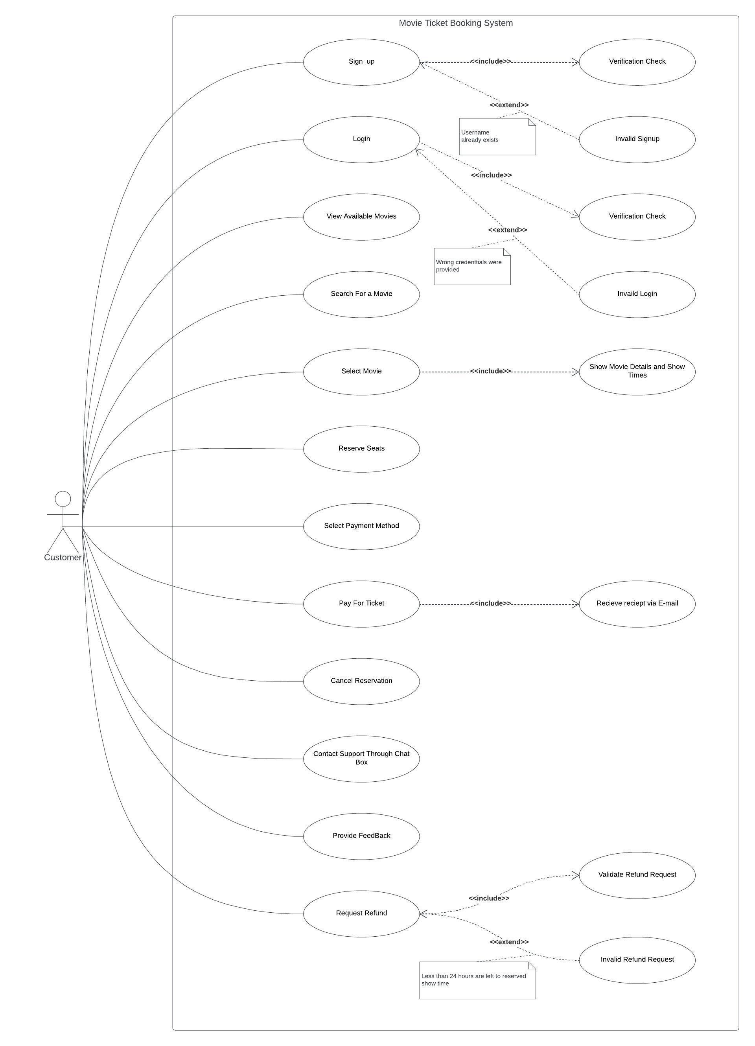

### 4.1.2. Admin Use-case

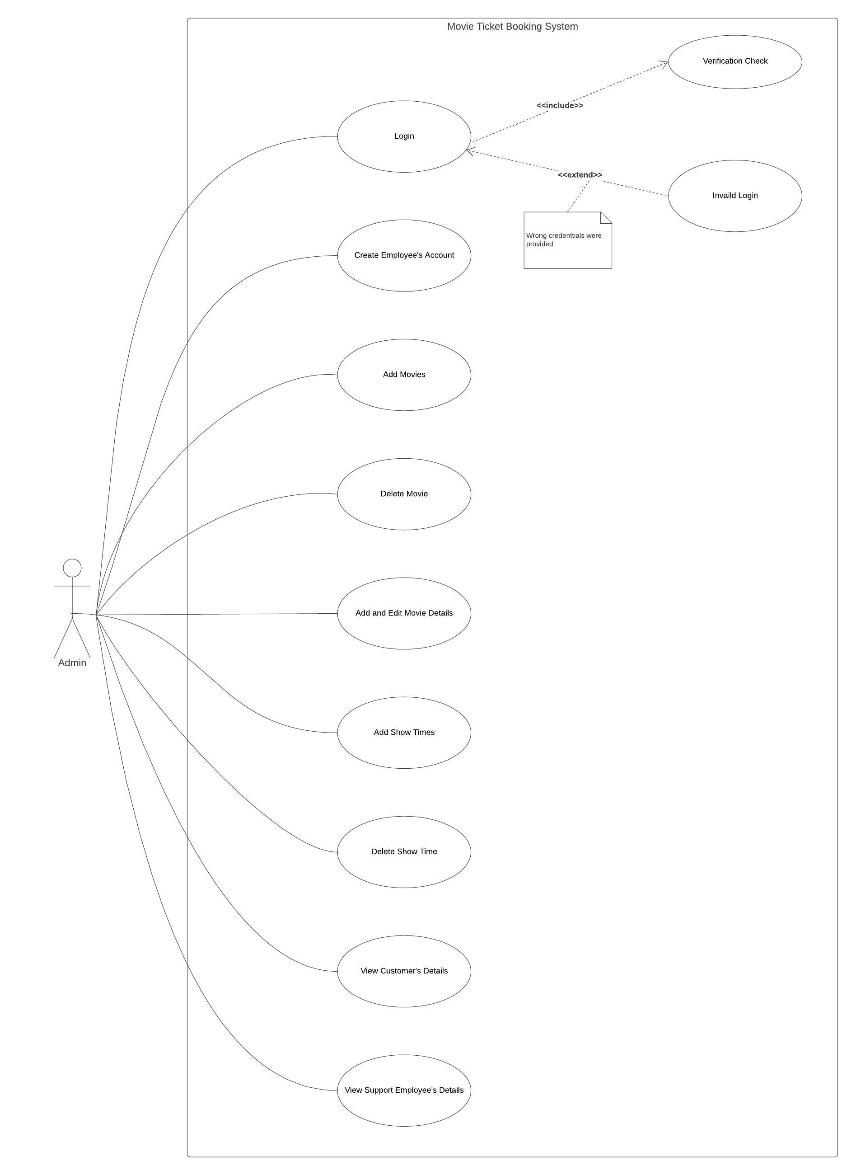

### 4.1.3. Support employee Use-case

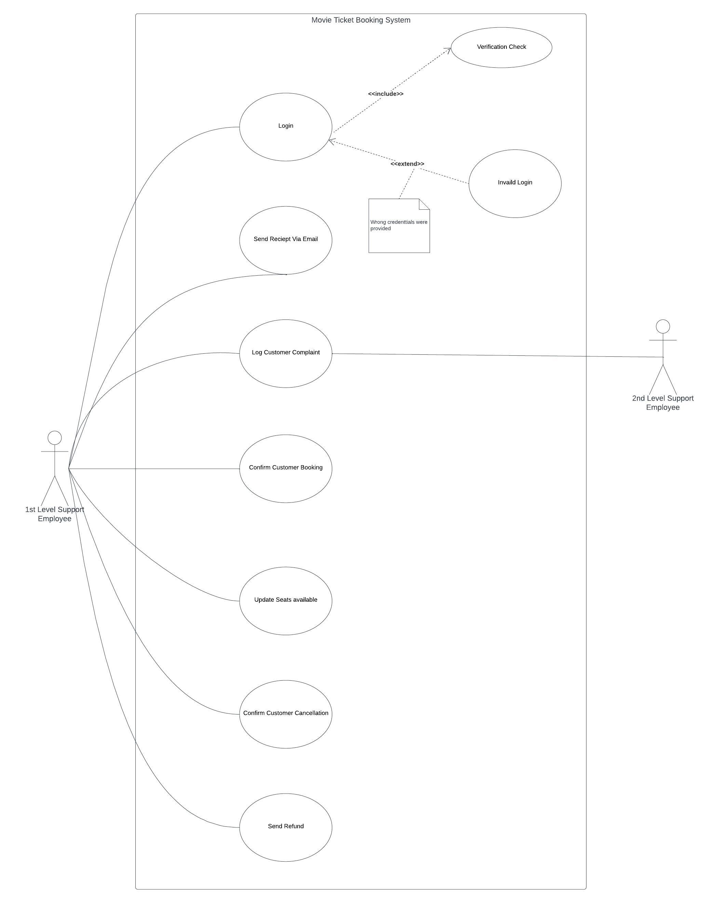

## 4.2. Narrative Description of all use cases

### 4.2.1. Customer Use cases Description

* Use-case 1:

|  |  |  |
| --- | --- | --- |
| **Use case name:** | Sign up | |
| **Related requirement:** | None | |
| **Goal in context:** | Customer requests creating new account from admin | |
| **Precondition:** | None | |
| **Successful end:** | New account is created for customer | |
| **Failure end:** | Request is rejected | |
| **Primary actor:** | Customer | |
| **Secondary actor:** | None | |
| **Main flow:** | Include: | |
|  | Step | Action |
| 1 | customer signs up with username and password |
| 2 | System validates the username if there is already a matching one |
| 3 | Customer’s new account is created |
| Extension: |  |
| Step | Action |
| 2.1 | Username not available (an account has same username) |
| 2.2 | Display error message” username invalid” |
|  | | |

* Use-case 2:

|  |  |  |
| --- | --- | --- |
| **Use case name:** | Login | |
| **Related requirement:** | None | |
| **Goal in context:** | Log Customer into their account | |
| **Precondition:** | Customer has an account | |
| **Successful end:** | Customer succeeds to home page | |
| **Failure end:** | Customer goes back to login page | |
| **Primary actor:** | Customer | |
| **Secondary actor:** | None | |
| **Main flow:** | Include: | |
|  | Step | Action |
| 1. | Customer provides username and password |
| 2. | System validates the username and password to match those in DB |
| 3. | Customer is redirected to homepage |
| Extension: |  |
| Step | Action |
| 2.1 | Username and password don’t match |
| 2.2 | Customer is redirected to login page to try again |
| 2.3 | Display error message” password or username invalid” |
|  | | |

* Use-case 3:

|  |  |  |
| --- | --- | --- |
| **Use case name:** | View available movies | |
| **Related requirement:** | Login | |
| **Goal in context:** | An available movies page is shown | |
| **Precondition:** | None | |
| **Successful end:** | Customer moves to available movies page | |
| **Failure end:** | Customer goes back to login page | |
| **Primary actor:** | Admin | |
| **Secondary actor:** | None | |
| **Main flow:** | 1. | Customer presses view available movies |
|  | 2. | system gets details from DB |
|  | 3. | available movies details are viewed by Customer |

* Use-case 4:

|  |  |  |
| --- | --- | --- |
| **Use case name:** | Search for a movie | |
| **Related requirement:** | Login | |
| **Goal in context:** | Customer finds a certain movie by searching | |
| **Precondition:** | None | |
| **Successful end:** | Customer moves to required movie | |
| **Failure end:** | Customer goes back to login page | |
| **Primary actor:** | Admin | |
| **Secondary actor:** | None | |
| **Main flow:** | 1. | Customers searches for a movie |
|  | 2. | System searches and get data from DB |
|  | 3. | Customer views required movie |

* Use-case 5:

|  |  |  |
| --- | --- | --- |
| **Use case name:** | Select a Movie | |
| **Related requirement:** | Login |  |
| **Goal in context:** | A movie is selected | |
| **Precondition:** | View available movies | |
| **Successful end:** | Movie’s details and show time page appears | |
| **Failure end:** | Customer is still in Available movies page | |
| **Primary actor:** | Customer | |
| **Secondary actor:** | None |  |
| **Main flow:** | **Include:** | |
|  | Step | Action |
|  | 1 | Customer views available movies |
|  | 2 | Customer selects movie’s posters |
|  | 3 | System gets data from DB |
|  | 4 | Customer views movies details and show times |

* Use-case 6:

|  |  |  |
| --- | --- | --- |
| **Use case name:** | Reserve seats | |
| **Related requirement:** | Select movie | |
| **Goal in context:** | Customer reserves a seat in desired movie time show | |
| **Precondition:** | Select movie and show time | |
| **Successful end:** | A seat is reserved for customer | |
| **Failure end:** | Reservation Request is rejected (seat not available) | |
| **Primary actor:** | Customer | |
| **Secondary actor:** | Support employee | |
| **Main flow:** | 1. | Customer selects desired showtime |
|  | 2. | Customer views available seats |
|  | 3. | Customer selects desired seat |
|  | 4. | Customer pays for reserved seats |
|  | 5. | Display message” reservation is successfully done” |
|  | **Extension:** | |
|  | Step | Action |
|  | 3.1 | Desired seat is not available |
|  | 3.2 | Display error message” This seat is reserved” |
|  | 3.3 | All seats for this movie are reserved |
|  | 3.4 | Display error message” No seats are available” |

* Use-case 7:

|  |  |  |
| --- | --- | --- |
| **Use case name:** | Pay for a ticket | |
| **Related requirement:** | Login |  |
| **Goal in context:** | A payment is done for reservation | |
| **Precondition:** | Reserve a seat | |
| **Successful end:** | Payment is done and customer receive receipt | |
| **Failure end:** | payment not completed | |
| **Primary actor:** | Customer | |
| **Secondary actor:** | None |  |
| **Main flow:** | **Include:** | |
|  | Step | Action |
|  | 1 | Customer chooses a payment method |
|  | 2 | Customer enters payment details |
|  | 3 | System validates payment information |
|  | **Extension:** | |
|  | Step | Action |
|  | 3.1 | Payment information is not valid |
|  | 3.2 | Display error message |
|  | 3.3 | Customer is redirected to payment page to try again |

* Use-case 8:

|  |  |  |
| --- | --- | --- |
| **Use case name:** | Cancel Reservation | |
| **Related requirement:** | Login |  |
| **Goal in context:** | cancellation is requested from First level supporter employee | |
| **Precondition:** | Reservation payment is done | |
| **Successful end:** | Booking is cancelled | |
| **Failure end:** | Contact support employee | |
| **Primary actor:** | customer | |
| **Secondary actor:** | Support employee | |
| **Main flow:** | **Include:** | |
|  | Step | Action |
|  | 1. | Customer requests cancellation for a reserved seat |
|  | 2. | Customer gets payment refund |
|  | 3. | System validates cancellation request |
|  | 4. | Seats are updated in DB |
|  | **Extension:** | |
|  | 1.1 | Customer cannot get a refund (24h is left for show time) |
|  | 1.2 | Display error message “can’t get refund” |

* Use-case 9:

|  |  |  |
| --- | --- | --- |
| **Use case name:** | Contact support through a chat box | |
| **Related requirement:** | Login |  |
| **Goal in context:** | Customer sends message to support for a certain issue | |
| **Precondition:** | None |  |
| **Successful end:** | Customer chats with support employee | |
| **Failure end:** | Customer goes back to login page | |
| **Primary actor:** | Admin |  |
| **Secondary actor:** | None |  |
| **Main flow:** | 1. Customers presses contact support | |
|  | 2. | Customers chats with support employee |

* Use-case 10:

|  |  |  |
| --- | --- | --- |
| **Use case name:** | Provide feedback | |
| **Related requirement:** | Login |  |
| **Goal in context:** | Customer sends feedback | |
| **Precondition:** | None |  |
| **Successful end:** | Customer successfully sends feedback | |
| **Failure end:** | Customer goes back to login page | |
| **Primary actor:** | Admin |  |
| **Secondary actor:** | None |  |
| **Main flow:** | 2. Customers presses send feedback | |
|  | 3. | Customers answers some questions for feedback |

* Use-case 11:

|  |  |  |
| --- | --- | --- |
| **Use case name:** | Request refund | |
| **Related requirement:** | Login |  |
| **Goal in context:** | Customer requests refund for a paid movie | |
| **Precondition:** | Cancel reservation | |
| **Successful end:** | Customer request refund is done | |
| **Failure end:** | Customer request is denied | |
| **Primary actor:** | admin | |
| **Secondary actor:** | None |  |
| **Main flow:** | **Include:** | |
|  | Step | Action |
|  | 1 | Customer requests a refund for a paid movie |
|  | 2 | Customer gets payment refund |
|  | 3 | Display message “refund is successful” |
|  | **Extension:** | |
|  | Step | Action |
|  | 1.1 | Customer cannot get refund (24h is left for show time) |
|  | 1.2 | Display error message” we cannot send refund, 24h is left for show |
|  | time’’ |  |

### 4.2.2. Support employee Use cases Description

* Use-case 1:

|  |  |  |
| --- | --- | --- |
| **Use case name:** | Login |  |
| **Related requirement:** | | |
| **Goal in context:** | Log supporter employee into their account | |
| **Precondition:** | supporter employee has an account | |
| **Successful end:** | supporter employee succeeds to home page | |
| **Failure end:** | supporter employee goes back to login page | |
| **Primary actor:** | supporter employee | |
| **Secondary actor:** | None |  |
| **Main flow:** | **Include:** | |
|  | Step | Action |
|  | 1 | supporter employee provides username and password |
|  | 2 | System validates the username and password to match those in DB |
|  | 3 | supporter employee is redirected to homepage |
|  | **Extension:** | |
|  | Step | Action |
|  | 1.1 | Username and password do not match |
|  | 1.2 | Display error message” password or username invalid” |
|  | 1.3 | supporter employee is redirected to login page to try again |

* Use-case 2:

|  |  |
| --- | --- |
| **Use case name:** | Send Receipt via email |
| **Related requirement:** | login |
| **Goal in context:** | Send user a receipt after payment confirmation |
| **Precondition:** | Confirm customer booking |
| **Successful end:** | A message “receipt is sent” is shown to supporter employee |
| **Failure end:** | supporter employee goes back to booking confirmation page |
| **Primary actor:** | supporter employee |
| **Secondary actor:** | None |
| **Main flow:** | 1. Supporter employee checks if booking payment is done |
|  | 2. Supporter employee sends the customer the receipt via mail |
|  | 3. Message is shown “receipt is sent” |

* Use-case 3:

|  |  |
| --- | --- |
| **Use case name:** | Log customer complaint |
| **Related requirement:** | login |
| **Goal in context:** | Check and reply for customer complaints |
| **Precondition:** | None |
| **Successful end:** | Supports employee goes to customers’ complaints page |
| **Failure end:** | supporter employee goes back to login page |
| **Primary actor:** | First level supporter employee |
| **Secondary actor:** | Second level supporter employee |
| **Main flow:** | 1. Checks complaints sent by customers |
|  | 2. First level support employee replies to complaints he can solve |
|  | 3. First level support employee sends technical issues to second level |
|  | support employee |

* Use-case 4:

|  |  |  |
| --- | --- | --- |
| **Use case name:** | Confirm customer Booking | |
| **Related requirement:** | Login |  |
| **Goal in context:** | Booking is confirmed for customer | |
| **Precondition:** | customer books for certain movie | |
| **Successful end:** | Booking is confirmed and reserved seats becomes not available in showtime | |
| **Failure end:** | Contact admin | |
| **Primary actor:** | First level supporter employee | |
| **Secondary actor:** | None |  |
| **Main flow:** | **Include:** | |
|  | Step | Action |
|  | 1 | supporter employee checks selected seats |
|  | 2 | supporter employee checks selected time shows |
|  | 3 | supporter employee checks payment for reservation |
|  | 4 | Seat is reserved successfully for the customer |
|  | **Extension:** | |
|  | Step | Action |
|  | 2.1 | payment information is not valid (payment not completed) |
|  | 2.2 | Sends message” you must complete your payment first” |

* Use-case 5:

|  |  |  |
| --- | --- | --- |
| **Use case name:** | Update seats available | |
| **Related requirement:** | login | |
| **Goal in context:** | Supports employee adds new seats /deletes reserved seats | |
| **Precondition:** | None | |
| **Successful end:** | Available seats successfully updated to movies | |
| **Failure end:** | supporter employee goes back to login page | |
| **Primary actor:** | First level supporter employee | |
| **Secondary actor:** | None | |
| **Main flow:** | 1. Supporter employee checks seats reserved to delete from available | |
|  |  | seats |
|  | 2. Supporter employee adds new available seats | |
|  | 3. | Seats are updated in DB |

* Use-case 6:

|  |  |  |
| --- | --- | --- |
| **Use case name:** | Confirm customer Cancellation | |
| **Related requirement:** | Login |  |
| **Goal in context:** | Booking is cancelled for customer | |
| **Precondition:** | customer booking is confirmed | |
| **Successful end:** | Booking is cancelled and reserved seats become available in showtime | |
| **Failure end:** | Contact admin | |
| **Primary actor:** | First level supporter employee | |
| **Secondary actor:** | None |  |
| **Main flow:** | 1. | supporter employee checks selected time shows |
|  | 2. | supporter employee cancels booking |
|  | 3. | supporter employee makes seat available for booking |
|  | 4. | Seats are updated in DB |

* Use-case 7:

|  |  |  |
| --- | --- | --- |
| **Use case name:** | Send refund | |
| **Related requirement:** | login | |
| **Goal in context:** | Send customer money refund | |
| **Precondition:** | customer payment is done | |
| **Successful end:** | Refund is sent to customer | |
| **Failure end:** | supporter employee goes back to login page | |
| **Primary actor:** | First level supporter employee | |
| **Secondary actor:** | None | |
| **Main flow:** | 1. Supporter employee checks payment status | |
|  | 2. Supporter employee checks whether it is within 24h | |
|  | 3. | Supporter employee sends customer refund |

### 4.2.3. Admin Use cases Description

* Use-case 1:

|  |  |  |
| --- | --- | --- |
| **Use case name:** | Login |  |
| **Related requirement:** | | |
| **Goal in context:** | Log admin into their account | |
| **Precondition:** | admin has an account | |
| **Successful end:** | admin succeeds to home page | |
| **Failure end:** | Admin goes back to login page | |
| **Primary actor:** | admin | |
| **Secondary actor:** | None |  |
| **Main flow:** | **Include:** | |
|  | Step | Action |
|  | 1. | admin provides username and password |
|  | 2. | System validates the username and password to match those in DB |
|  | 3. | admin is redirected to homepage |
|  | **Extension:** | |
|  | Step | Action |
|  | 2.1 | Username and password don’t match |
|  | 2.2 | Display error message” password or username invalid” |
|  | 2.3 | admin is redirected to login page to try again |

* Use-case 2:

|  |  |  |
| --- | --- | --- |
| **Use case name:** | Creates Employee’s account | |
| **Related requirement:** | login | |
| **Goal in context:** | Create new account for employee | |
| **Precondition:** | None | |
| **Successful end:** | A new employee account is created | |
| **Failure end:** | Admin goes back to login page | |
| **Primary actor:** | Admin | |
| **Secondary actor:** | None | |
| **Main flow:** | 1. | Admin enters the employee’s data |
|  | 2. | Admin presses create new account |
|  | 3. | Employees data is stored in DB |

* Use-case 3:

|  |  |  |
| --- | --- | --- |
| Use case name: | Add Movies | |
| Related requirement: | Login |  |
| Goal in context: | A new movie poster and details to be added | |
| Precondition: | None |  |
| Successful end: | Movie is added to available movies page | |
| Failure end: | Movie is not added due to technical issue | |
| Primary actor: | Admin |  |
| Secondary actor: | None |  |
| Main flow: | Include: | |
|  | Step | Action |
|  | 1 | admin checks available movies |
|  | 2 | admin adds new movies posters and show times |
|  | 3 | new movies and its details are stored in DB |

* Use-case 4:

|  |  |  |
| --- | --- | --- |
| **Use case name:** | Delete Movies | |
| **Related requirement:** | Login | |
| **Goal in context:** | A movie poster and details to be deleted | |
| **Precondition:** | None | |
| **Successful end:** | Movie is deleted from available movies page | |
| **Failure end:** | Movie is not deleted due to technical issue | |
| **Primary actor:** | Admin | |
| **Secondary actor:** | None | |
| **Main flow:** | 1. | admin checks available movies |
|  | 2. | admin deletes movie posters and show times |
|  | 3. | movies data is deleted from DB |

* Use-case 5:

|  |  |
| --- | --- |
| **Use case name:** | Add and Edit movie details |
| **Related requirement:** | Login |
| **Goal in context:** | A movie poster and details to be edited |
| **Precondition:** | None |
| **Successful end:** | Movie details is edited in available movies page |
| **Failure end:** | Movie details is not edited due to technical issue |
| **Primary actor:** | Admin |
| **Secondary actor:** | None |
| **Main flow:** | 1. admin checks available movies details |
|  | 2. admin edits movie posters and show times |
|  | 3. movies data is updated in DB |

* Use-case 6:

|  |  |  |
| --- | --- | --- |
| **Use case name:** | Add show times | |
| **Related requirement:** | Login | |
| **Goal in context:** | A movie show times is added | |
| **Precondition:** | None | |
| **Successful end:** | Movie show times is added in available movies page | |
| **Failure end:** | Movie details is not added due to technical issue | |
| **Primary actor:** | Admin | |
| **Secondary actor:** | None | |
| **Main flow:** | 1. | admin checks available movies show times |
|  | 2. | admin adds new movie show times |
|  | 3. | show times details is added to DB |

* Use-case 7:

|  |  |  |
| --- | --- | --- |
| **Use case name:** | Delete show times | |
| **Related requirement:** | Login | |
| **Goal in context:** | A movie show times is deleted | |
| **Precondition:** | None | |
| **Successful end:** | Movie show times is deleted in available movies page | |
| **Failure end:** | Movie details is not deleted due to technical issue | |
| **Primary actor:** | Admin | |
| **Secondary actor:** | None | |
| **Main flow:** | 1. | admin checks available movies show times |
|  | 2. | admin deletes movie show times |
|  | 3. | movies show time is deleted from DB |

* Use-case 8:

|  |  |  |
| --- | --- | --- |
| **Use case name:** | View customer’s details | |
| **Related requirement:** | Login | |
| **Goal in context:** | A customer’s details /profile is shown | |
| **Precondition:** | None | |
| **Successful end:** | Admin moves to customer’s details page | |
| **Failure end:** | Admin goes back to login page | |
| **Primary actor:** | Admin | |
| **Secondary actor:** | None | |
| **Main flow:** | 1. | admins presses view customers details |
|  | 2. | system gets details from DB |
|  | 3. | Customer’s details are viewed by admin |

* Use-case 9:

|  |  |  |
| --- | --- | --- |
| **Use case name:** | View Support employee’s details | |
| **Related requirement:** | Login | |
| **Goal in context:** | A Support employee’s details /profile is shown | |
| **Precondition:** | None | |
| **Successful end:** | Admin moves to Support employee’s details page | |
| **Failure end:** | Admin goes back to login page | |
| **Primary actor:** | Admin | |
| **Secondary actor:** | None | |
| **Main flow:** | 1. | admins presses view Support employee details |
|  | 2. | system gets details from DB |
|  | 3. | Support employee’s details is viewed by admin |

# 5. Swimlane Diagrams

## 5.1. Booking process

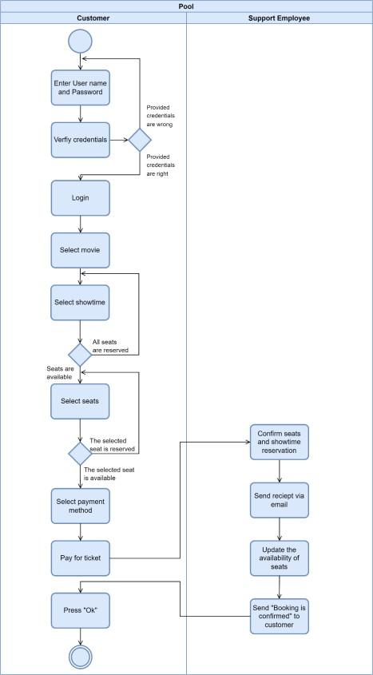

## 5.2. Cancellation process

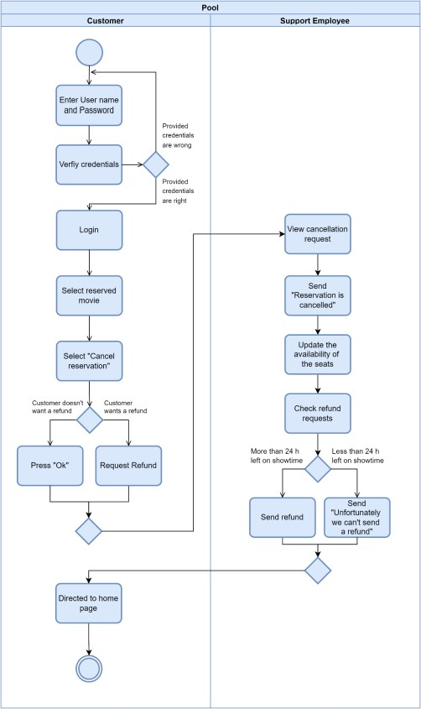

## 5.3. Customer support

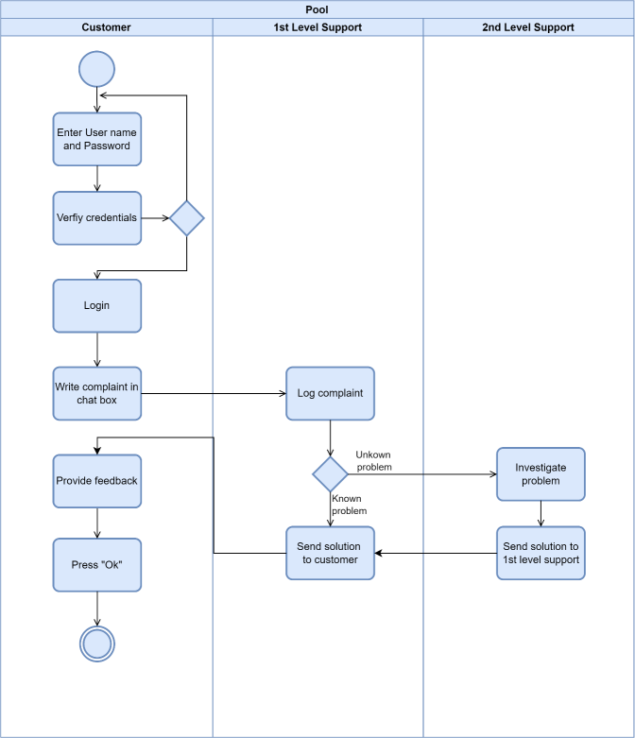

Activity Diagrams

Admin Login

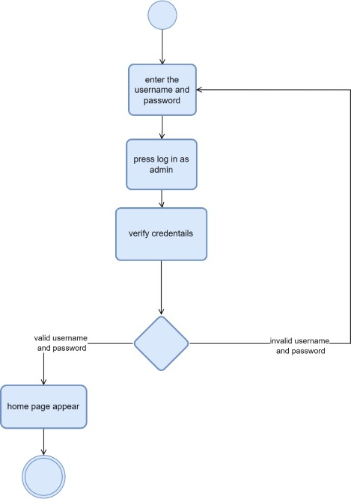

Customer sign-up

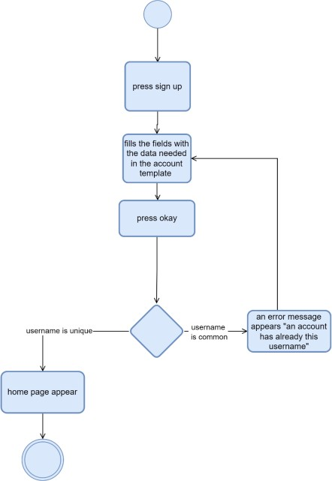

Provide Feedback

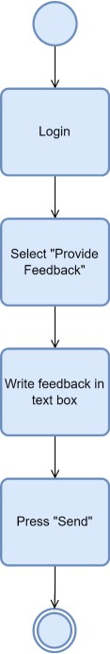

Select and view movie

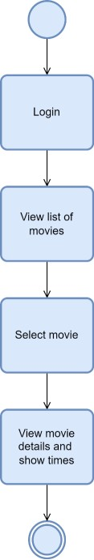

Create employee’s account

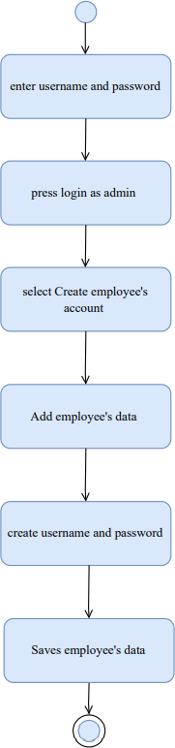

Add Movie

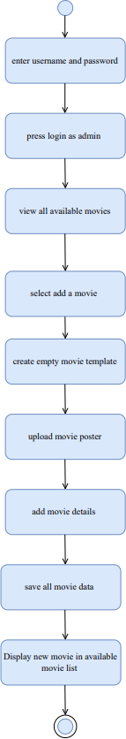

Delete Showtime

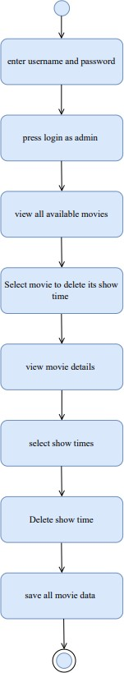

# 6. Interaction Diagrams

## 6.1. Customer Sequence diagram

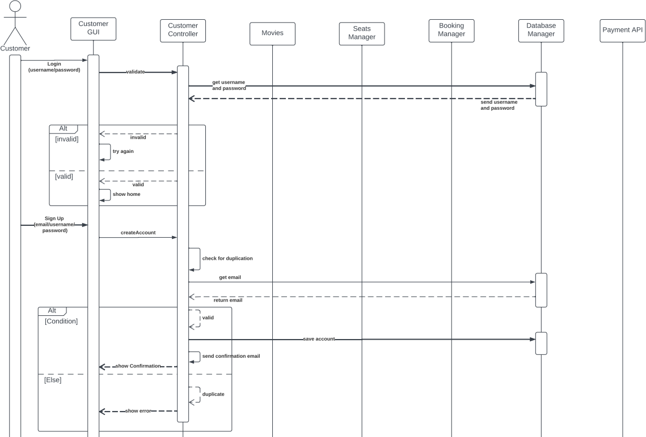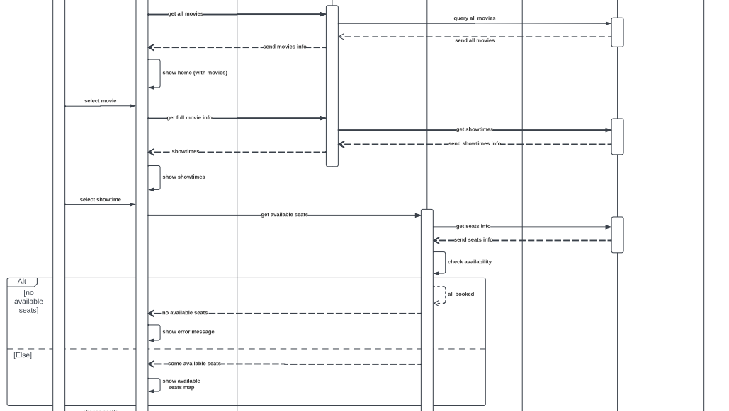

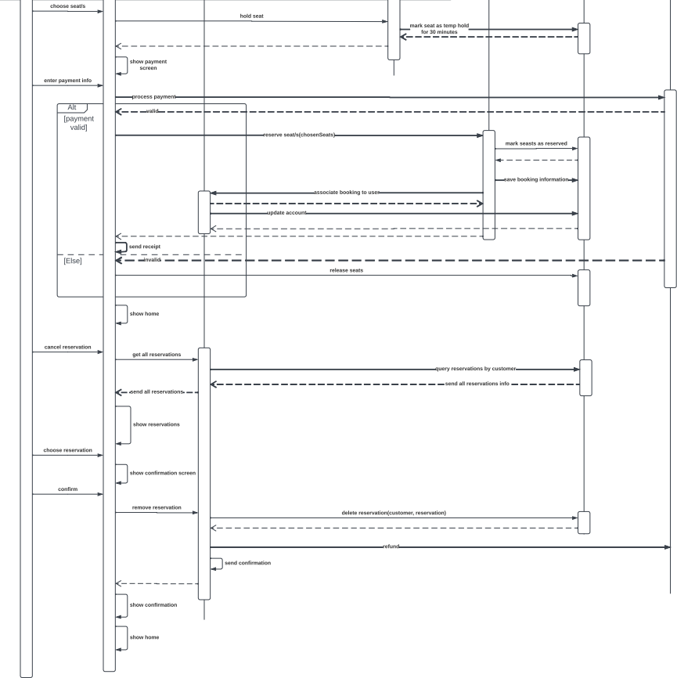

## 6.2. Employee Sequence diagrams

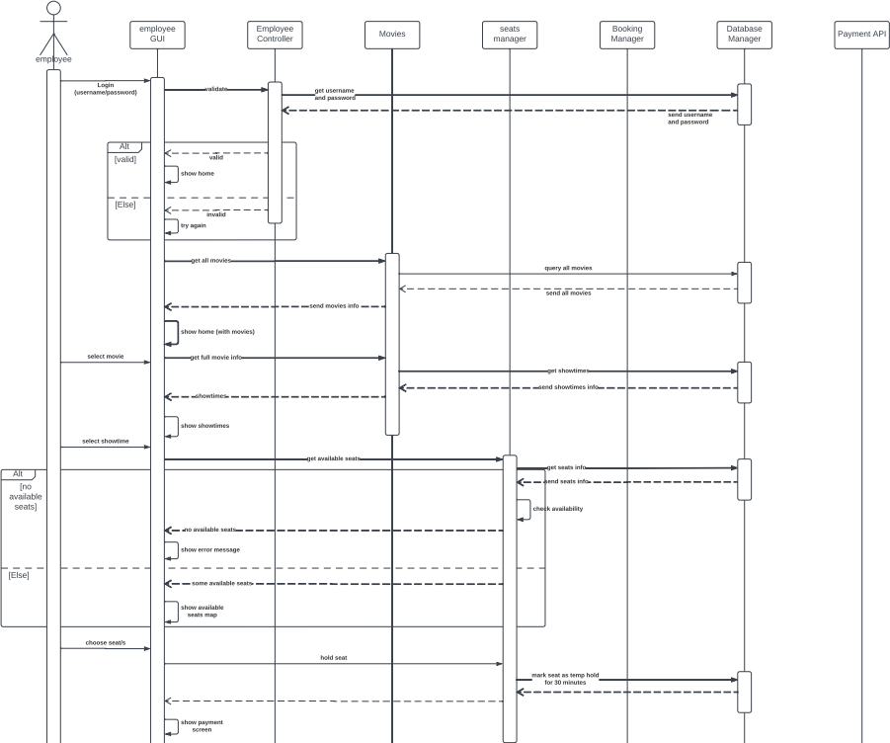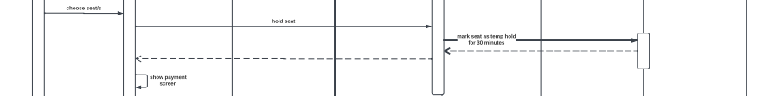

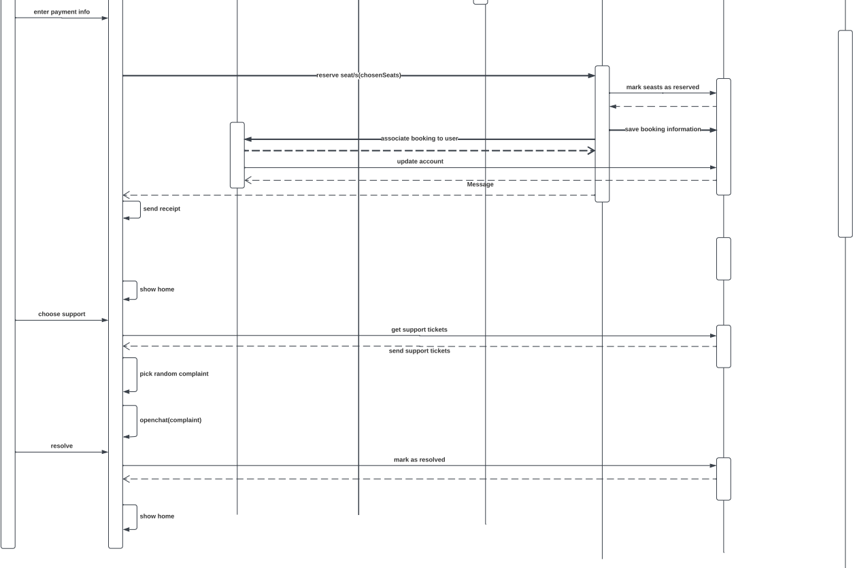

## 6.3. Admin Sequence diagrams

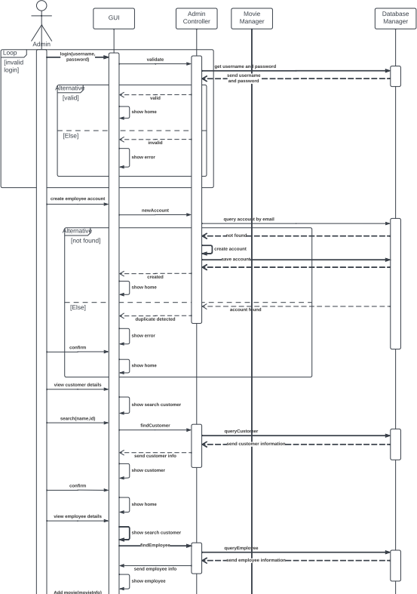

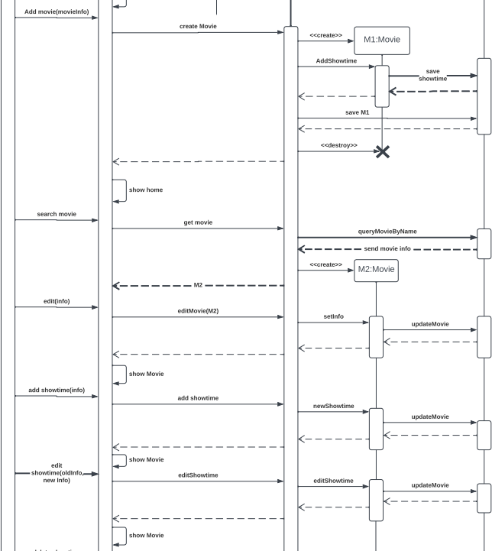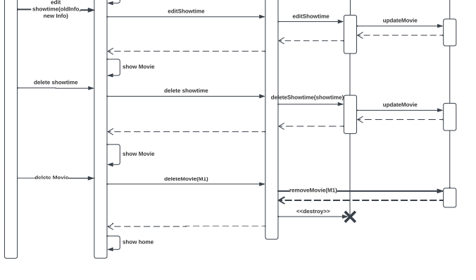

# 7. Noun Extraction and CRC Cards

## 7.1. Noun extraction

The following nouns are extracted:

System, Cinema, Customers, Seats, Users, Admin, Support employee, Accounts, Movies, Show times, Reservation requests, Phone, Email, Payment, Application, Receipt, Refund

* System: We cannot have a class of the system because it would be too general, not a class.
* Cinema: The cinema itself is out of the scope of the system, not a class.
* Customers: We need a class called Customer to store the data of the customer, Class: **Customer**.
* Seats: We need a class to store the data of the seats and handle it reservation operations,

Class: **Seat**.

* Users: Same as the customer class, not a class.
* Admin: we need a class to control the system so the admin class will have this responsibility,

Class: **Admin**.

* Support employee: We need a class to store the employee’s data and handle the employee operations, Class: **Employee**.
* Accounts: We already have a class for the employees and the customers so no need for accounts class, not a class.
* Movies: We need a class to store the data of the movies, Class: **Movie**.
* Show times: We need a class to store the data of a show times and should contain the movie itself and the seats of the hall, Class: **ShowTime**.
* Reservation requests: Reservations will be received by phone, mail, or from the app so there will be no need to make a class for the reservation, not a class.
* Phone: Out of scope, not a class.
* Email: Out of scope, not a class.
* Payment: The payments should be handled by the payment API, so it is out of scope, not a class.
* Application: We cannot have a class of the application because it would be too general, not a class.
* Receipt: We need a class to store the payments data, Class: **Receipt**.
* Refund: Refunds should be handled by the payment API, so it is out of scope, not a class

## 7.2.CRC Cards

### 7.2.1. First Iteration

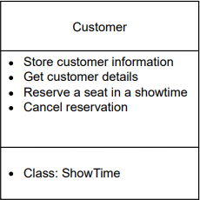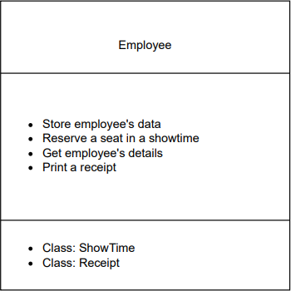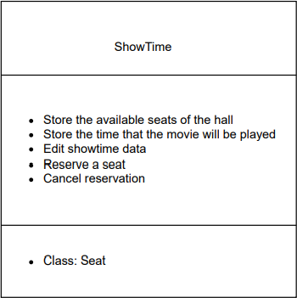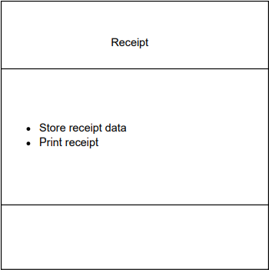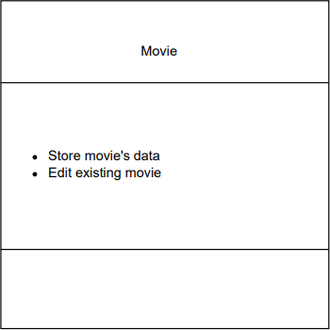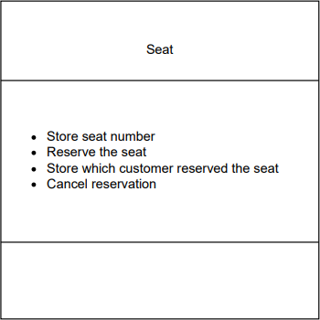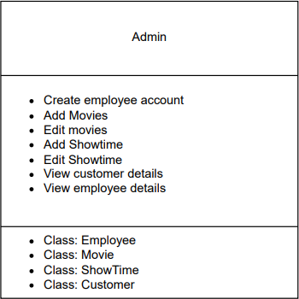

### 7.2.2. Second Iteration

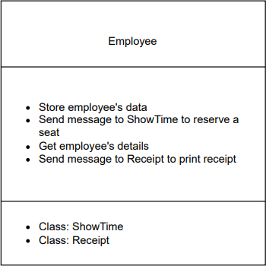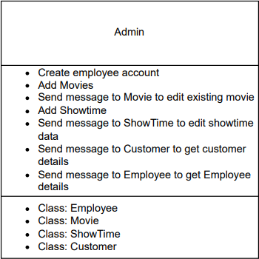

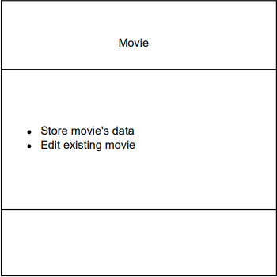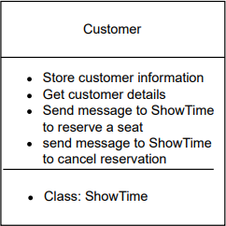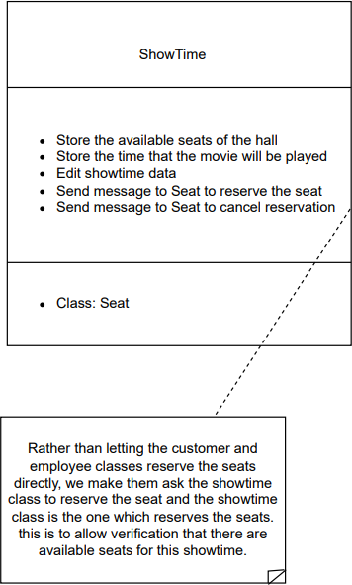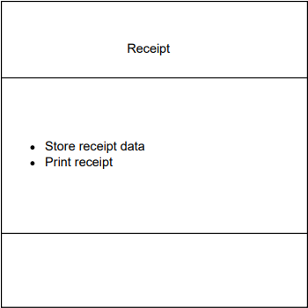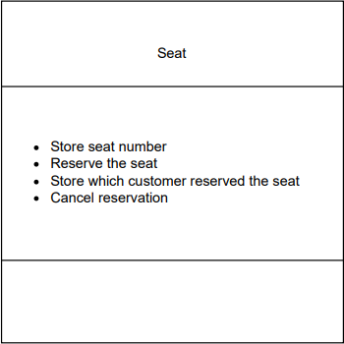

# 8. Class Diagram

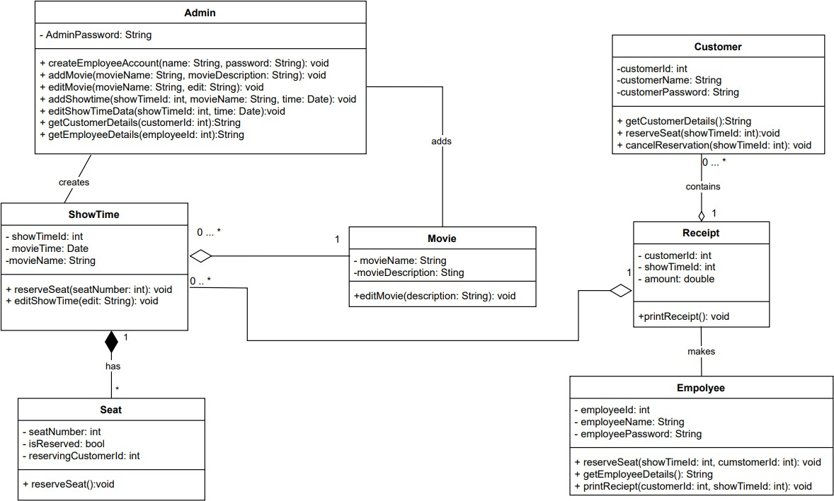

# 9. State Diagram

## 9.1. Customer state diagram

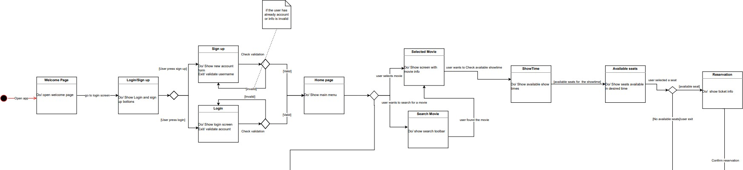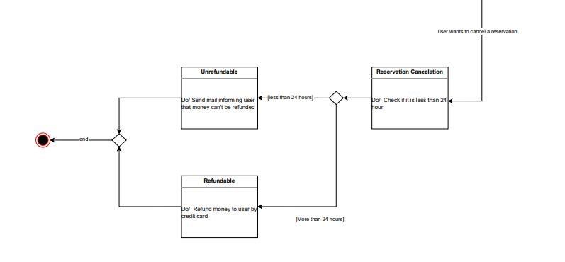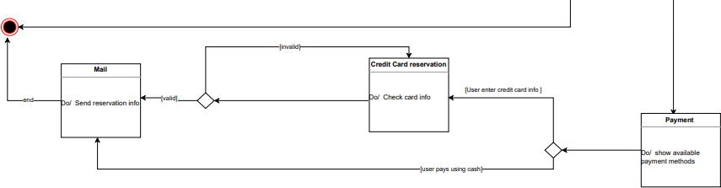

## 9.2. Admin state diagram

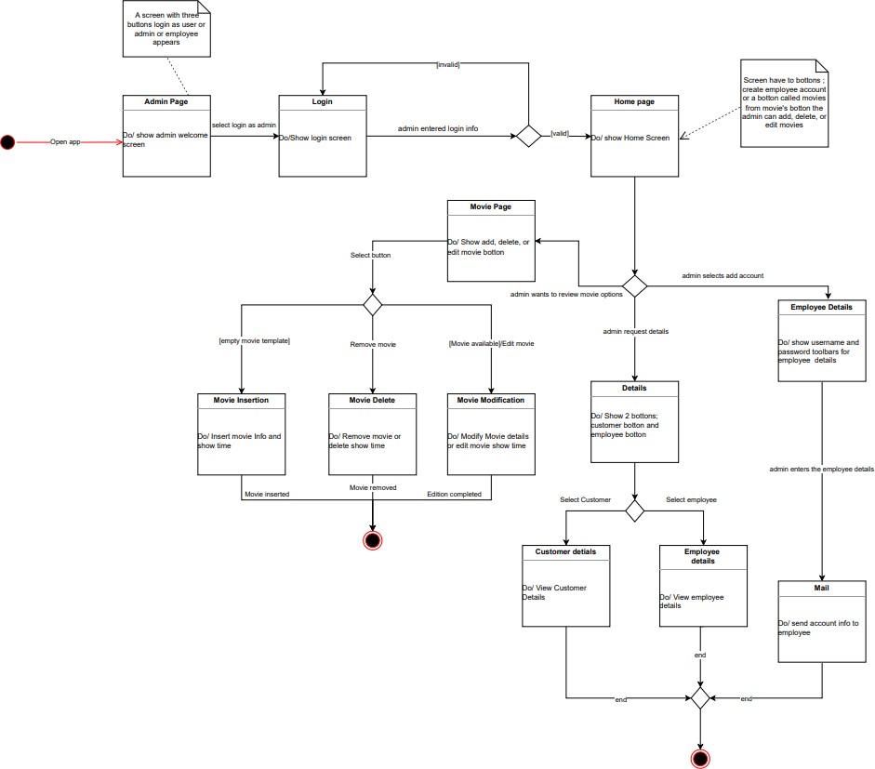

## 9.3. Support employee state diagram

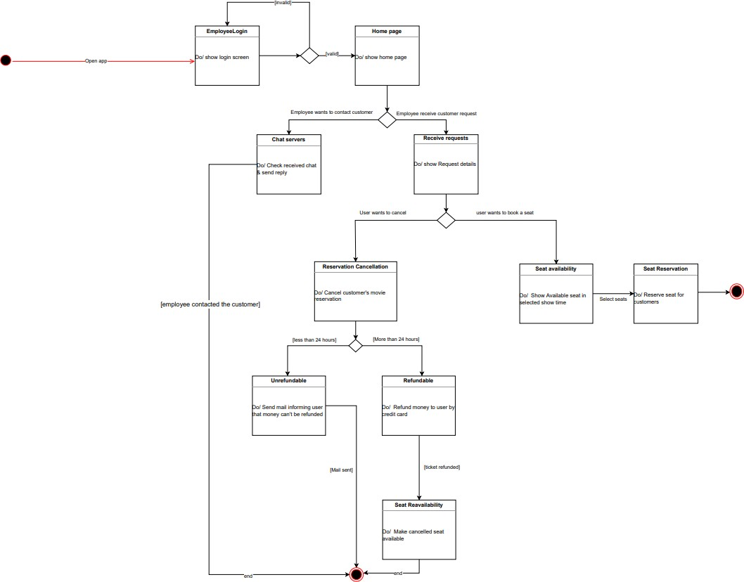

# 10. Client-Object Relation Diagram

A user object is instantiated in the main according to the type of login (either admin of employee or customer).

Admin:

* The admin can create a customer object to get the data of a customer.
* The admin can create a movie object to add it to the available movie.
* The admin can create a show time to add a new show time for a movie.
* The admin can create an employee object to create an account for a new employee.

Employee:

* The employee can create a receipt object to print the receipt for the customer.
* The employee can create a show time object to reserve a seat in the show time.

Customer:

* The customer can create show time object to reserve a seat in the show time.

ShowTime:

* The show time can create a seat object to reserve the seat.

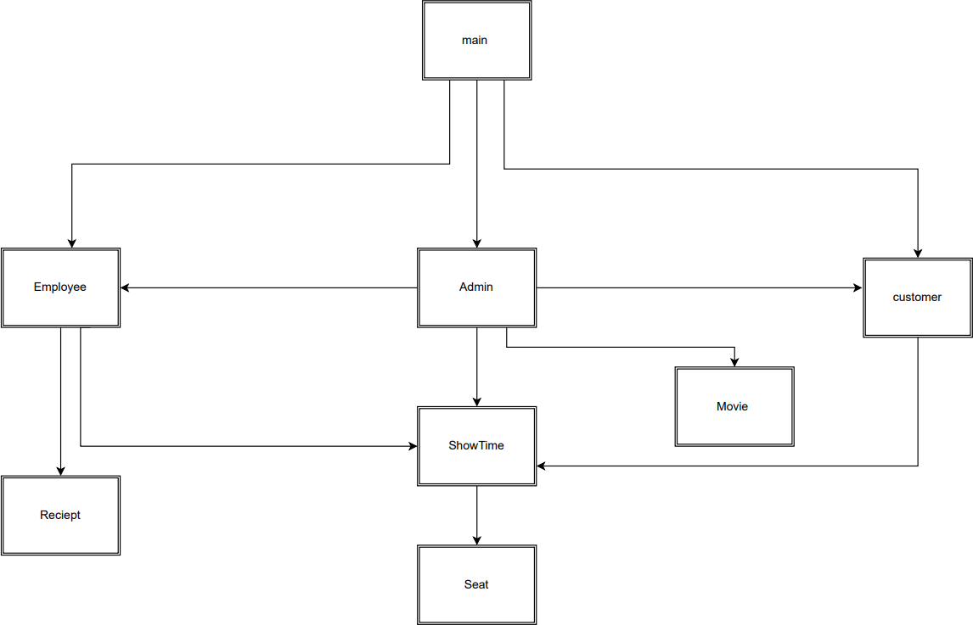

# 11. OOAD Methodologies

To implement this project, we used two methodologies:

* Rumbaugh’s OMT
* Jacobson's methodology

## 11.1. Rumbaugh’s OMT

We applied Rumbaugh’s OMT as out first methodology. It consists of three related but different viewpoints that capture important aspects of the ticket booking system which are the static, dynamic and functional behaviors of our system.

The entire OMT software development process has three phases:

1. Analysis: The aim of analysis phase is to build a model of the real-world situation to show its important properties and domain. We started with defining a problem statement for our system which included a set of goals and is then expanded into the three models (object model, dynamic model, functional model). We applied the three models by generating class diagram, state diagram and DFD diagrams.
2. System design: To create the overall system architecture and high-level structure. We divided our system into sub-systems such as: Movie manager, Seat manager, booking manager, Database manager, Chat, and the payment API these subsystems are then assigned to processes and tasks while taking concurrency and cooperation into account.
3. Object design: We were concerned with thoroughly categorizing all current and remaining classes, relationships, properties, and actions required to achieve a problem solution.

* Classes were determined such as: Admin, Customer, Employee, Seat, Movie, Receipt and Show Time.
* Relationships between classes are determined (such as: association, aggregation, inheritance, composition) in the class diagram.

UML diagrams

1. Object modelling represented by the class diagram. It defines the structure of the system's objects, including their identity, connections to other objects, properties, and activities. It comprises classes that are linked together by Association lines (composition, aggregation, association, inheritance) which build links between the classes.
2. Dynamic modelling as illustrated by state diagrams and event flow diagrams. It provides a complete and thorough dynamic model that displays states, transitions, events, and actions. Each state gets one or more events that cause it to go to the next stage. The next stage is determined by the existing situation as well as events.
3. Functional modelling in OMT describes the whole processes and actions using data flow diagram (DFD). It focuses on how data is flowing, where data is stored and how it is processed by the different processes. It provides a simple and intuitive method describing business processes without focusing on the details of computer system.

### 11.1.1. DFD diagram

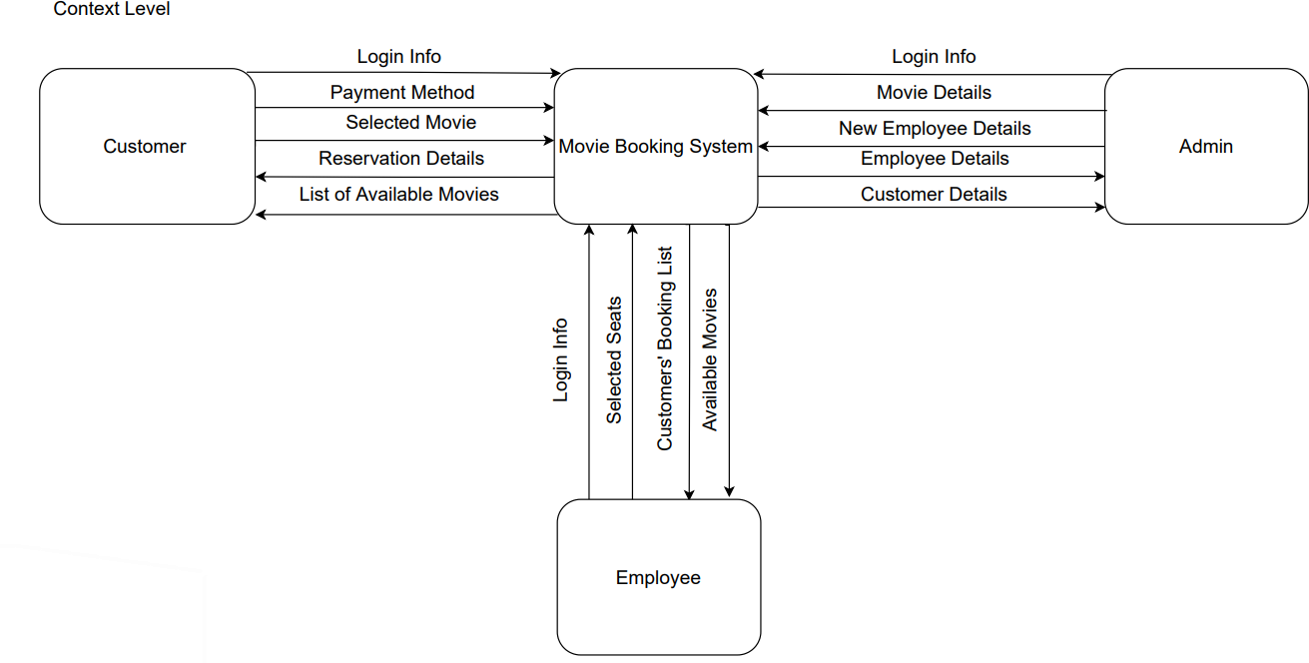

Level 0

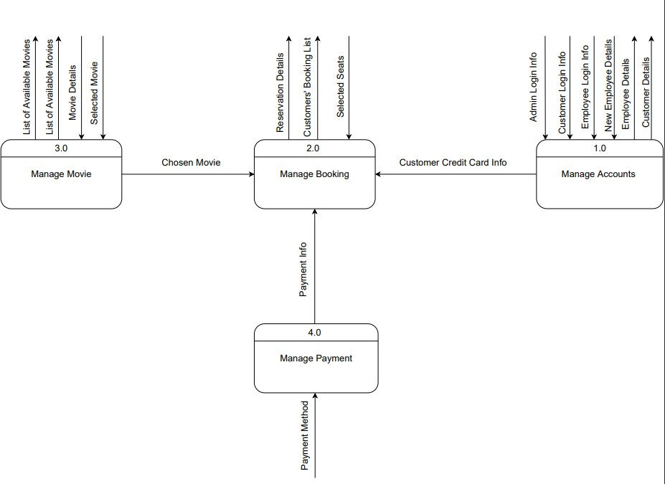

Level 1 for 1.0 Manage Accounts

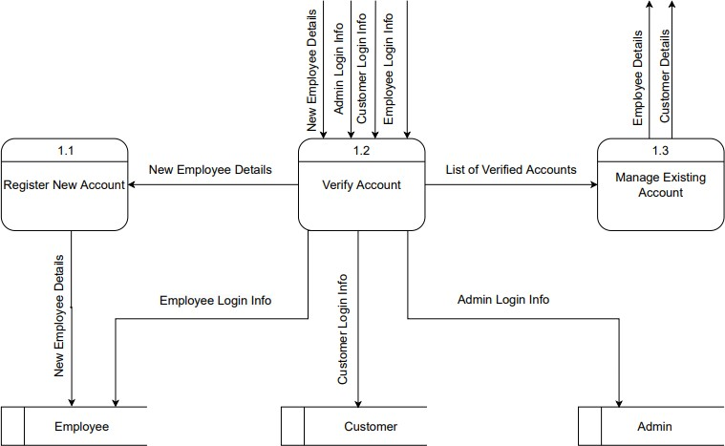

Level 1 for 2.0 Manage Booking

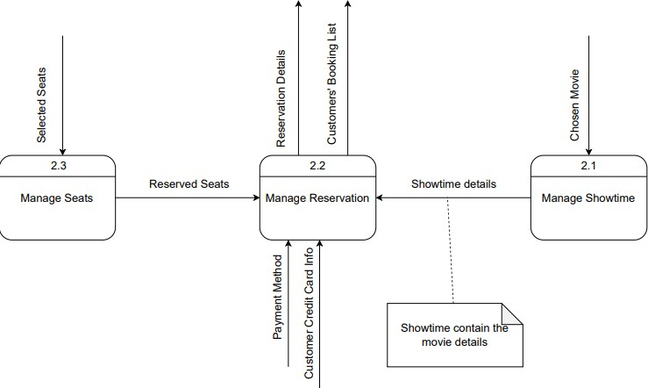

**Level 1 for 3.0 Manage Movie**

## 11.2. Jacobson’s methodology

The second method we implemented was the Jacobson method invented by Ivar Jacobson, a method for planning, designing, and implementing object-oriented software. We focused on implementing the concept of use cases which was created by him and using a use-case diagram with narrative descriptions.

It is broken down into three models which are:

1. Requirements: The problem domain is created and use cases are selected from the list of system requirements that we formed.
2. Design object model: State diagrams are made which are common with Rambaugh’s OMT.
3. Analysis object model: A dynamic view of the system is developed using class diagram which is common with Rambaugh’s OMT.

UML diagrams

1. Use-case diagram: a diagram that shows the relationships among actors and use cases within a system.
2. State diagram: It provides a complete and thorough dynamic model that displays states, transitions, events, and actions. Each state gets one or more events that cause it to go to the next stage.
3. Class diagram: It defines the structure of the system's objects, including their identity, connections to other objects, properties, and activities.

# 12. Comparative Analysis of the Output of the Adopted Methodologies

## 12.1. Rumbaugh’s OMT

Advantages:

1. It allowed a complete specification of the booking system, covering its static structure, dynamic behavior, and functionality.
2. It simulated entities needed for the project before constructing them.
3. Made communication easier.
4. Helped to reduce complexity of requirements through visualization.
5. Worked well with the object-oriented programming languages.

Disadvantages:

1. There was no exact way to extract the classes and their objects it totally depends on our understanding, so we used noun extraction and CRC cards method to get a precise view of the classes.
2. As the objects got more complex, sophisticated searches and operations may be performed considerably faster than in relational models. However, if the operations are simple, the complicated structure must still be employed, resulting in a performance loss.
3. There was a lack of an explicit mechanism to capture timing constraints and real-time issues. There was also a high risk that information can be fragmented across various diagrams and models.

## 12.2. Jacobson methodology

Advantages:

1. It covers the entire life cycle of the software system and stresses on the traceability between the different phases.
2. Use cases are easy to understand as they are written in natural language hence, they provide an excellent way for communication.
3. Use cases can manage the complexity of large projects by decomposing the system into functions called use cases.

Disadvantages:

1. The transition from analysis objects to design blocks (and the block classes) is not clearly specified, making it difficult to maintain traceability.
2. It generates several classes whose primary purpose is to coordinate other objects.

# 13. Architectural Model

MVC Model

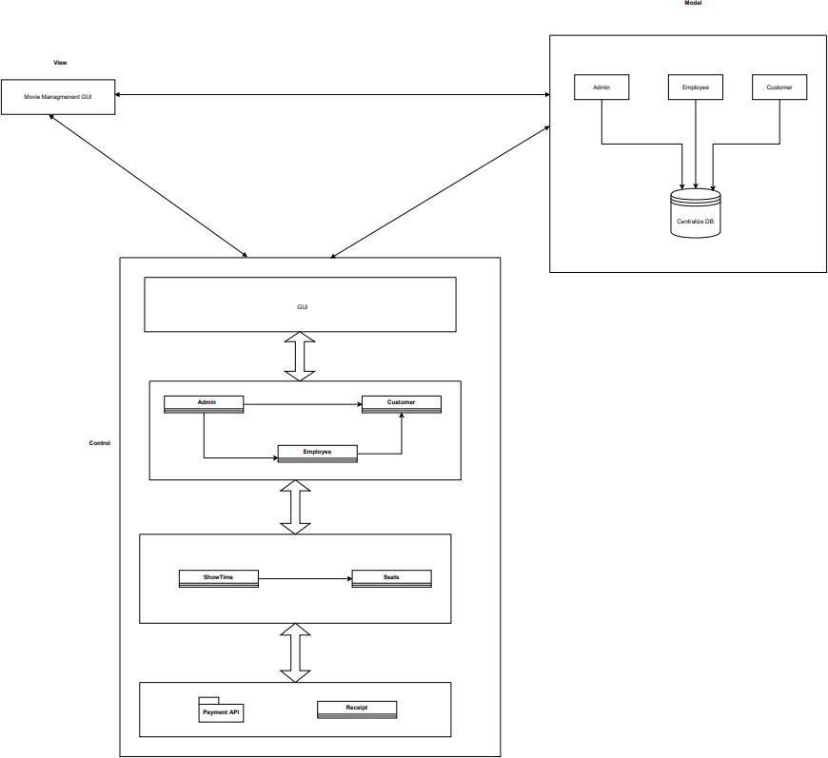We chose to mainly use the MVC architectural style to separate the backend and the front end for security. We also used the layered architecture when designing the control of the system to better organize the system into layers of classes and API where each layer can communicate with the adjacent layers. We also used the repository architecture to allow the users access to their information in the data base where each user has different privileges.

# 14. Component diagram

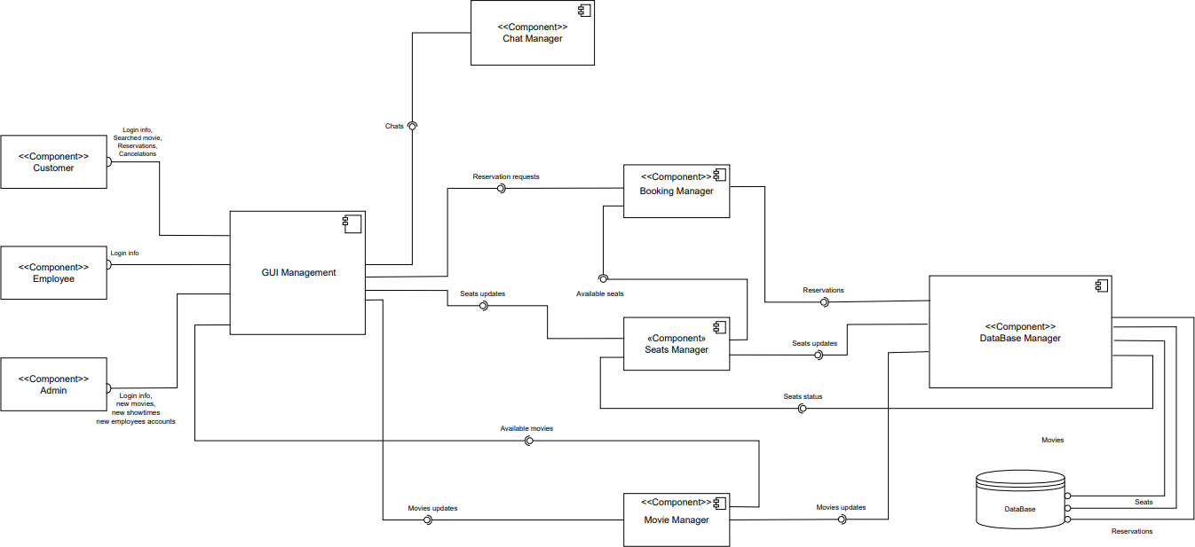

# 15.Time Plan

Firstly, the project was announced at the beginning of February 2023. We created a team to work on that project. We started to come up with ideas for the project and proposals starting on the 25th of February then we settled on a ticket booking system after one week of deliberations. The following week a full description of the application and its requirements and constraints was written. All of us worked on the UML diagrams while a selected team from the group worked on both the code and the diagrams. The diagrams were drawn between 15th and 30th of March 2022 in parallel with the backend coding which started on 1st of April and ended on 30th of April.

|  |  |  |  |  |  |  |  |  |  |  |  |  |  |
| --- | --- | --- | --- | --- | --- | --- | --- | --- | --- | --- | --- | --- | --- |
| Task Name | February | | March | | | | April | | | | May | | |
| Generation of project idea |  |  | |  | |  | |  | |  | |  |  |
| Generation of project description and requirements |  |  | |  | |  | |  | |  | |  |  |
| UML Diagrams |  |  | |  | |  | |  | |  | |  |  |
| Backend Coding |  |  | |  |  | | |  | |  | |  |  |
| GUI |  |  | |  | |  | |  | |  | |  |  |
| Final Documentation |  |  | |  | |  | |  |  | | |  |  |
| Code Testing |  |  | |  | |  | |  | |  | |  |  |

# 16. User Guide

## 16.1. User path

1. This will be the first interface upon launching the Website
2. The user is required to enter his username, E-mail and password in the following 3 text fields

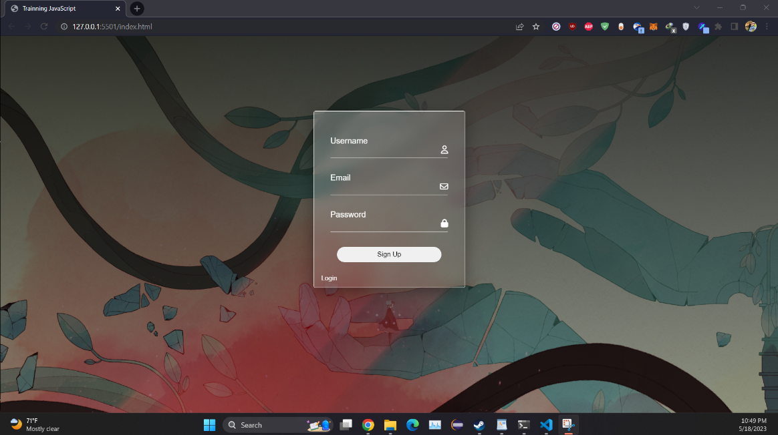

3. After signup the login page will appear

4. The user is required to enter his E-mail and password in the following 2 text fields

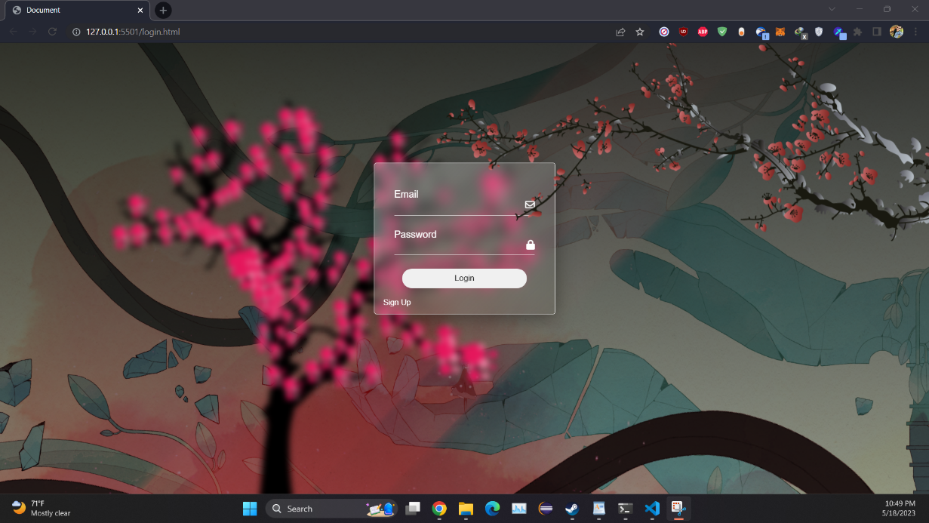

5. After login user go to Homepage

6. User Can access another pages with navigation bar at homescreen

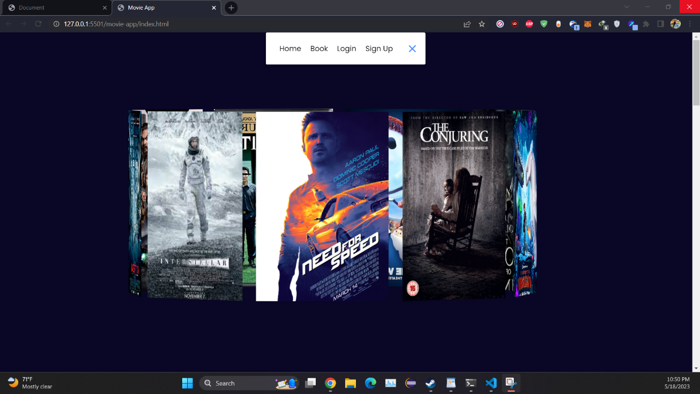

7.Scrrolling Down to access search API

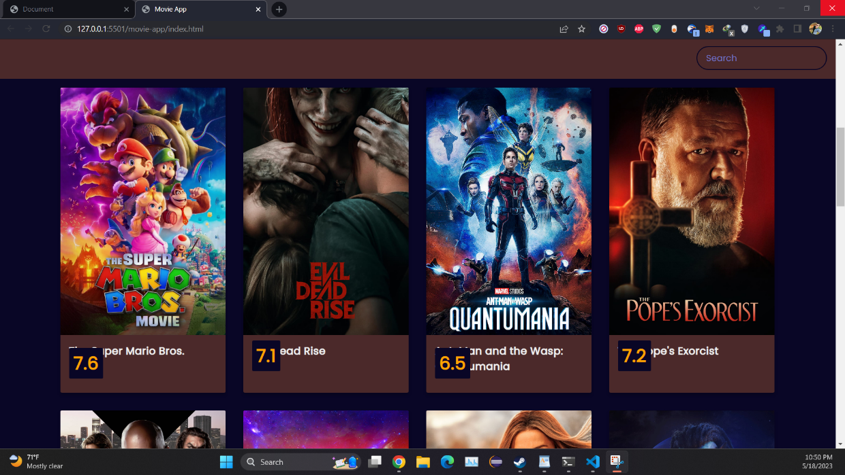

8. Choosing any movie the user will go to booking page

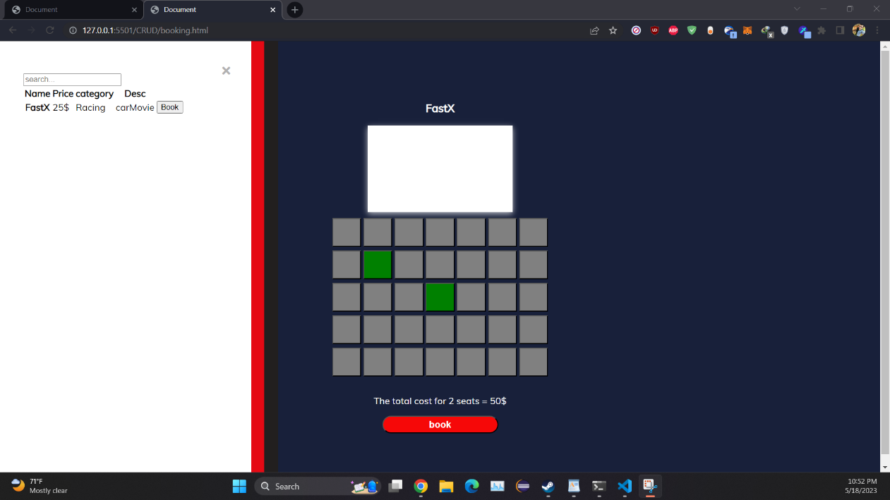

9. After Choosing The Seats and click book button alert will popup with total cost

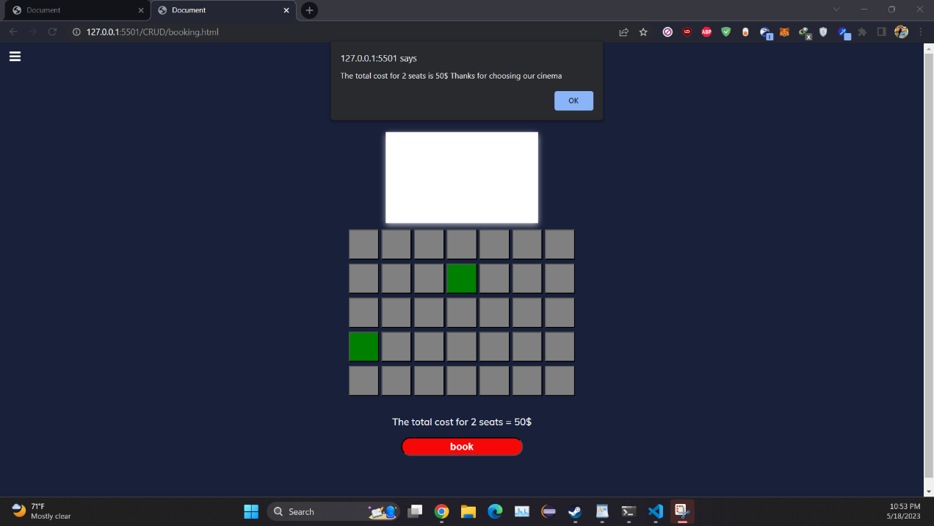

## 16.2. Admin Path

1. Admin Can Login with E-mail and password of admin is ”admin” for both

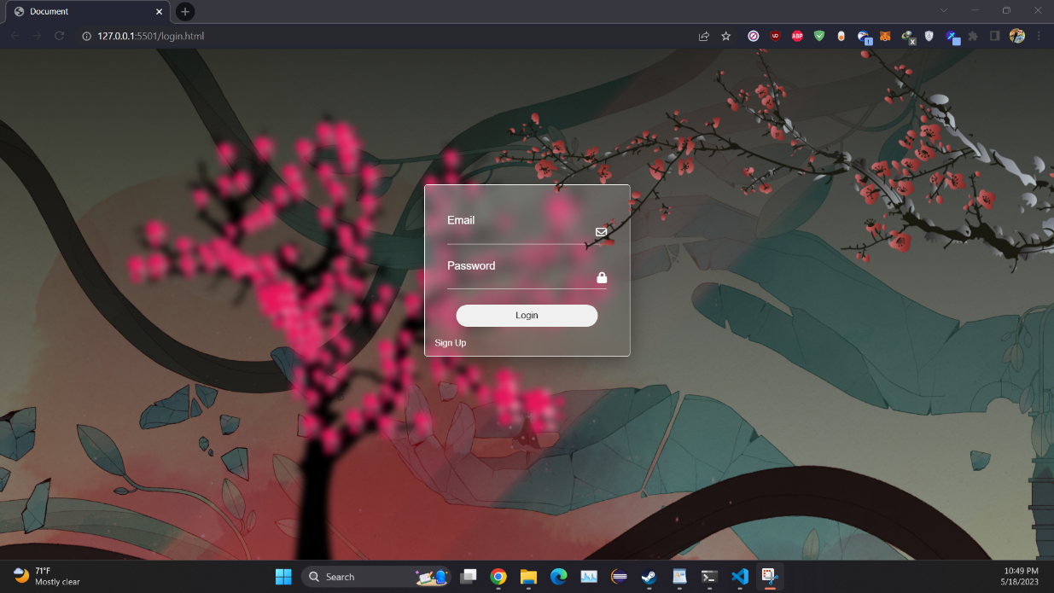

2. After Login as admin he will access admin panel

3. He can Add the Movie Name, Price, Category and Description

4. The Admin Panel Validate the input data and show error messages if exist

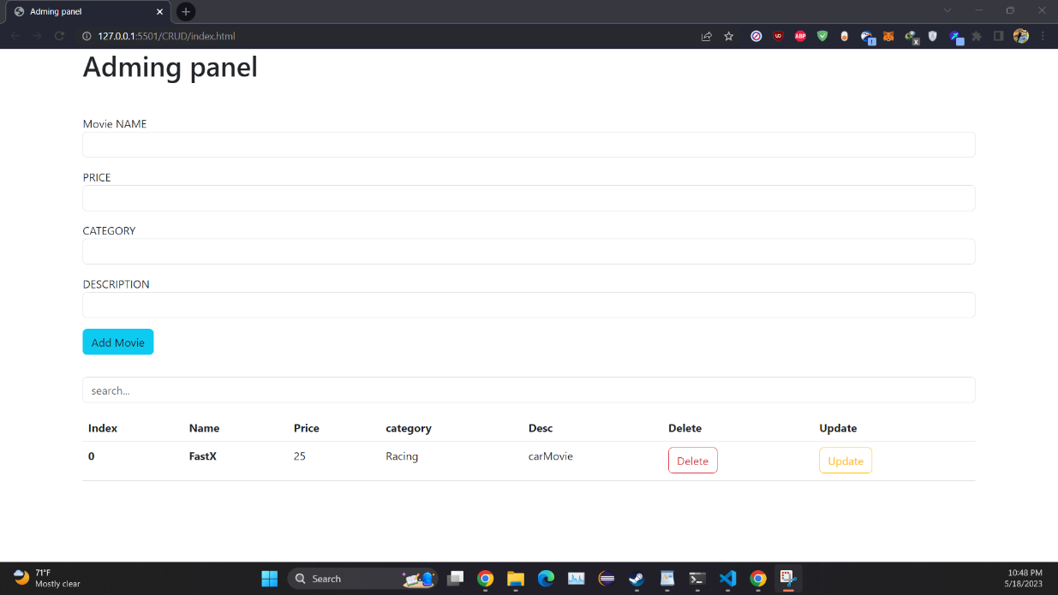

# 17. Appendices

Appendix A: Glossary of Terms

* + Movie theater: A place where films are shown on a big screen for the public to watch.
  + Movie ticket: A piece of paper or electronic document that grants the holder the right to watch a movie at a specific time and date.
  + Seat: A place where a person can sit in a movie theater to watch a movie.
  + Showtime: The time at which a movie is scheduled to start.
  + Ticket booking: The process of reserving a seat for a specific movie and showtime.
  + Payment gateway: A service that facilitates transactions between customers and businesses by securely processing payment information.
  + Confirmation number: A unique identification number assigned to a successful ticket booking transaction.
  + Cancellation policy: The rules and procedures governing the cancellation of a ticket booking and the refund of any associated fees.
  + User account: A personal account created by a user on our website to manage their ticket bookings and preferences.

Appendix B: Frequently Asked Questions

Q: Can I cancel my ticket booking?

A: Yes, you can cancel your ticket booking up to a certain time before the showtime. Please refer to our cancellation policy for more information.

Q: What payment methods do you accept?

A: We accept credit cards and cash on theatre.

Q: How do I receive my movie tickets?

A: You can choose to receive your tickets as an electronic document that you can print or show on your mobile device, or you can pick them up at the theater box office.

Q: Can I choose my seat?

A: Yes, you can choose your seat from the available options when you make your ticket booking.

Q: What happens if I miss the showtime?

A: Unfortunately, we cannot provide refunds or exchanges for missed showtimes. Please make sure to arrive at the theater on time.

# 18. Research report

## 18.1. Object Oriented Methodology

The object-oriented methodology is a way of viewing software components and their relationships. There are many object-oriented methodologies:

* The Rumbaugh et al. OMT
* The Booch methodology
* Jacobson’s methodology
* Rational Unified Process methodology (RUP)

### 18.1.1. The Rumbaugh et al. OMT

One of the first OO methodologies was OMT (Object Modelling Technique), which Rumbaugh introduced in 1991.It introduces a method for the system's analysis, design, and implementation.

OMT phases

There are four stages:

1. Analysis

The design is given an object, dynamic, and functional model in this stage. It also establishes significant properties and domains.

2. System Design

The fundamental design of the system. It describes the program's fundamental system architecture. For example:

* identify global resources,
* divide the system into subsystems,
* identify boundary conditions,
* identify concurrency,
* assign subsystems and tasks,
* establish trade-off priorities,
* decide how to implement data stores
* decide how to implement software controls

3. Object Design

Object models that are static, dynamic, and functional. It establishes operations and data structures while classifying objects. Additionally, various associations and inheritance are examined

4. Application

This stage uses code to communicate design.

Analysis

The goal of the analysis is to build a model of the world. The requirements of the users, developers and managers provide the information needed to develop the initial problem statement. Once the initial problem is defined, there are three models to be done:

1. Object Model

* Depicts the object classes and their relationships as a Class Diagram and Data Dictionary.
* It describes the structure of objects in the system: their identity, relationships to other objects, attributes, and operations.

1. Dynamic Model

* Captures the behavior of the system over time in State Diagram and Event Flow Diagrams.
* It is a network of states and events and actions. Each state receives one or more events at which it makes the transition to the next step. The next step depends on the current state as well as events.

1. Functional Model

* A hierarchical set of Data Flow Diagrams (DFD). Shows flow of data between different processes in a system.
* DFD has four primary symbols
* Process: any function being performed
* Data Flow: Direction of data element movement
* Data Store: Location where data is stored
* External Entity: Source or Destination of a data element

Overall, the **Rumbaugh et al. OMT** methodology provides one of the strongest tools set for the analysis and design of object oriented

### 18.1.2. Booch methodology

Booth's methodology focuses on object-oriented analysis and design.

**Diagrams of Booch method**

* **Class diagrams**: describe roles and responsibilities of objects
* **Object diagrams**: describe the desired behavior of the system in terms of scenarios
* **State transition diagrams**: state of a class based on a stimulus
* **Module diagrams**: to map out where each class & object should be declared
* **Process diagrams**: to determine to which processor to allocate a process
* **Interaction diagrams**: describes behavior of the system in terms of scenarios

Booch method prescribes:

* **Macro** development process
* **Micro** development process

The macro process serves as a controlling framework for the micro process and can take weeks or even months.

**Macro development process**

In the macro process, the traditional phase of analysis and design to a large extent are preserved.

The steps are:

1. **Conceptualization**

During conceptualization, the code requirements of the system are established. Also, a set of goals are established, and a prototype is developed to prove the concept.

1. **Analysis & Development of the model**

A model is developed by defining object classes, their attributes, methods, and inheritance. Include associations, the dynamic part of a model. This is done by using class diagram to describes the roles and responsibilities objects are to carry out in performing the desired behavior of the system. Furthermore, using object diagram to describe that desired behavior of the system in terms of scenarios or alternatively, using the interaction diagram to describe behavior of the system in terms of scenarios.

1. **Design or create the system architecture**

Develop a structure/architecture where logical and physical details are discussed. In the design phase, Class diagram is used to decide what classes exist and how they relate to each other. Next, Object diagram is used to decide what mechanisms are used to regulate how objects collaborate. Then, Model diagram is used to map out where each class and objects should be declared. Process diagram is used to determine to which processor to allocate a process. Also, determine the schedules for multiple processes on each relevant processor.

1. **Evolution or implementation**

Successively refining the system through many iterations. Produce a stream or software implementations, each of which is a refinement of the prior one.

1. **Maintenance**

Maintenance following the delivery of the product

Micro development process

Each macro process has its own micro development process. The micro processes are a description of the day-to-day activities by a single or small group of software developers. It consists of the following steps:

* Identify classes and objects
* Identify class & objects semantics
* Identify class & object relationship
* Identify class & objects interface and implementation

### 18.1.3. Jacobson methodology

The Jacobson methodology, also known as Object-Oriented Software Engineering (OOSE), covers the entire life cycle and stress traceability between the different phases both forward and backward. This traceability enables reuse of analysis and design work, possibly much bigger factors in the reduction development time then reuse of code.

The main concept of the methodology is the use-case concept, which evolved with Objectory (Object Factory for Software Development).

Components

OOSE can be broken down into five separate components:

* **Requirements**: Create problem domain object diagram and specifies use case diagrams.
* **Analysis**: Analysis diagrams
* **Design**: State transition diagrams and interaction diagrams
* **Implementation**: Implementation of the model
* **Testing** **model**: Testing of the model

Use cases

Use cases are scenarios for understanding system requirements. A use case is an interaction between users and the system.

The use case description must contain:

* How and when the use case begins and ends.
* The interaction between the use case and its actors including when the interaction occurs and what is exchanged.
* How and when the use case will need data stored in the system or will store data in the system.
* Exception to the flow of events.
* How and when concepts of the problem domain are handled.\

Every single use case should describe one main flow of events. An exceptional or additional flow of events could be added. The exceptional use case **extends** another use case to **include** the additional one.

### 18.1.4. Rational Unified Process methodology (RUP)

It is a development process of object-oriented model and is known as unified process model. It was made by Rational Corporation, and UML was used in the design and documentation (Unified Modelling Language). The use-case driven, iterative (repeating the process), and incremental (increasing value) are some characteristics of RUP.

RUP phases:

There are 5 phases:

1. **Inception**

* The two main ones are communication and planning.
* Defines the project's scope using a use-case model that enables managers to calculate the costs and duration needed.
* Once the needs of the customer are known, creating a plan for the project is simple.
* The project description, use-case model, risks, and project plan are created.
* The milestone criteria are checked against the project, and if it does not meet them, the project may be cancelled or redesigned.

1. **Elaboration**

* The two main ones are planning and modelling.
* A thorough evaluation and development plan is implemented, which reduces the risks.
* Refine or change the business case, risks, and use-case model (about 80%).
* The project can be cancelled or redesigned if it could not pass the milestone criteria after being checked again.
* Baseline for executable architecture.

1. **Construction**

* The project has been developed and finished.
* System or source code creation is followed by testing.
* Coding is done.

1. **Transition**

* The public is given access to the finished product.
* Move the project from the development stage to the production stage.
* Refresh project records.
* Beta testing is carried out.
* Based on customer feedback, flaws are fixed in the project.

1. **Production**

* The final phase of the model.
* The project is maintained and updated accordingly.

## 18.2. Software Architecture

Software Architecture is the discipline used to create these structures and systems, as well as the basic structure of a software system. Each structure is made up of software elements, their connections, and the attributes of both the elements and the connections. A software system's architecture is a metaphor, like the architecture of a building. It serves as a blueprint for the system and the evolving project, allowing project management to extrapolate the tasks that must be carried out by the teams and individuals involved in the process later.

Software Architectural patterns

Architectural pattern provides a set of predefined subsystems, specifies their responsibilities, and includes rules and guidelines for organizing the relationships between them.

There are many architectural patterns:

* Layers
* Model-View-Controller (MVC)
* Client-Server

### 18.2.1. Layered Architecture

According to some sources, layered architecture is the most popular and widely used architectural framework in software development. This pattern is known as an n-tier architecture. A layer is a logical division of parts or program code. It also refers to an architectural pattern made up of numerous independent horizontal layers that work together to form a single software unit. Each layer can contact the layer below only and use its functionalities. Each layer is isolated so any modification can be happened in any layer and will not affect the other layers.

Advantages of layered architecture

* The framework is straightforward and simple to understand and use.
* Because each layer's function is distinct from the functions of the other layers, there is less dependency.
* Because the components are separated, testing is simpler because each component can be tested separately.
* Cost overheads are not excessive.

Disadvantages of layered architecture

* Scalability is challenging because the framework's structure prevents growth.
* They may be challenging to maintain. Because the system functions as a single entity, a change in a single layer can have an impact on the entire thing.
* Because a layer needs the layer above it to receive data, there is interdependence between the layers.
* There is no way to process data in parallel.

### 18.2.2. Model-View-Controller (MVC)

MVC Architecture is a software architectural pattern that is frequently applied to the creation of user interfaces and separates the related program logic into three interconnected parts. By doing this, it is possible to distinguish between internal representations of information and the ways in which information is provided to and received by users.

MVC composes of three components:

* Model: In charge of data logic.
* View: It gives the user access to the model's data.
* Controller: It manages the data flow into a model object and updates the view whenever data changes.

these components are connected to each other.

Advantages of MVC architecture

* The user interface and business logic will be separated by MVC architecture.
* Reusable components exist.
* Simple to maintain
* MVC applications allow for the independent deployment and upkeep of various components.
* This architecture made it possible to independently test components.

Disadvantages of MVC architecture

* There is a lot of complexity.
* Inadequate for minor applications.
* The ineffectiveness of data access.

### 18.2.3. Client-Server architecture

There are two primary elements in client-server architecture patterns:

* the client: is the service requester
* the server: is the service provider

Even though the client and server may both be present on the same system, they frequently communicate via a network using different pieces of hardware. To create the necessary services, the client component starts some interactions with the server. As Servers have ports that describe the services they offer, client components have ports that describe the required services. By request and reply connectors, both components are connected. The World Wide Web is a most common example for this architecture pattern.

Advantages of client-server architecture

* A client-server model’s main advantage is that it enables centralized management, so all clients can find all the information in one location, and This is very advantageous because the network administrator has total control over management and administration.
* Any problem that develops across the entire network may be fixed in one place. In addition, updating data is made simpler. Reusable components exist.
* It is easy and quick to increase the number of servers or clients and There are no issues with authorization to expand network resources because the server is centralized. As a result, the setups only call for a few individuals.
* Data is adequately protected as the client-server network's centralized design. so, the clients can only access the data with login and password as well as two-factor authentication if they are authorized users.
* if the data is lost, a single backup can quickly restore the records.
* it provides a good user interface, easy file finding procedure, and management system for organizing files.
* Easy sharing of resources across various platforms is possible.

Disadvantages of client-server architecture

* If the primary server goes down, the entire architecture is disrupted.
* It is expensive to operate because of the cost of heavy hardware and software tools.
* This architecture requires special operating system related to networking.
* Too many users at once can cause the problem of traffic congestion.
* It requires highly technical stuff, such as server machines, for maintenance of the network.